2025 Expedition to Kathmandu, Nepal
Investigating Women’s Inclusion and Voluntary Participation in Community-Based Disaster Risk Reduction (CBDRR) projects in Nepal
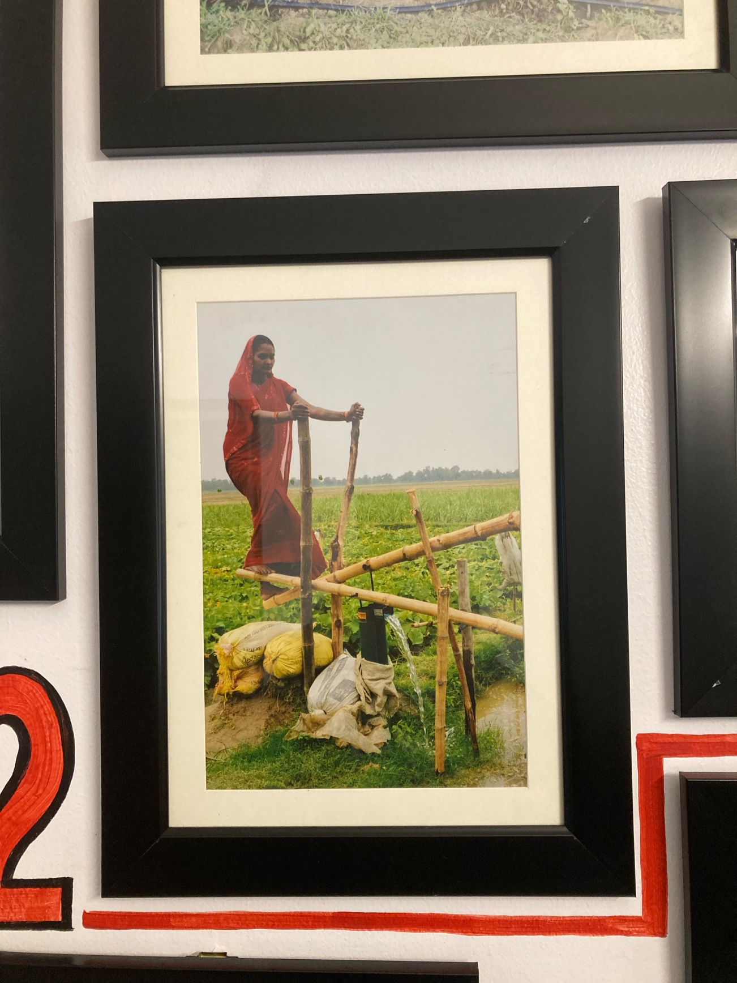

Contents Page
Contents Page…………………………………………………………………………………2
Title Page……………………………………………………………………………………….3
Acknowledgements……………………………………………………………………………4
Chapter 1: Introduction……………………………………………………………………….5
1.1. Disasters and Response in Nepal
1.2. Disasters as gendered
1.3. Women in decision making spaces
1.4. Intersectionality
1.5. A Feminist Political Ecology Framework
Chapter 2: Methodology………………………………………………………………………8
2.1. Feminist Methodological Approach
2.2. Focus groups and semi-structure interviews
2.2.1. Sampling and format
2.2.2. Rationale
2.3.3. Analysis
2.3. Methodological Issues
Chapter 3: Discussion Overview……………………………………………………………11
Chapter 4: Analysis - Women as water, not logs: overturning narratives of vulnerability………………………………………………………………………………………13
Chapter 5: Analysis - Fire needs fresh water, not stagnant ponds: the original contributions of women for disaster risk reduction……………………………………16
Chapter 6: Water isn’t homogenous: Remembering intersectionality………………18
Chapter 7: Conclusion………………………………………………………………………….20
Chapter 8: References List……………………………………………………………………21
Chapter 9: Appendices…………………………………………………………………………23
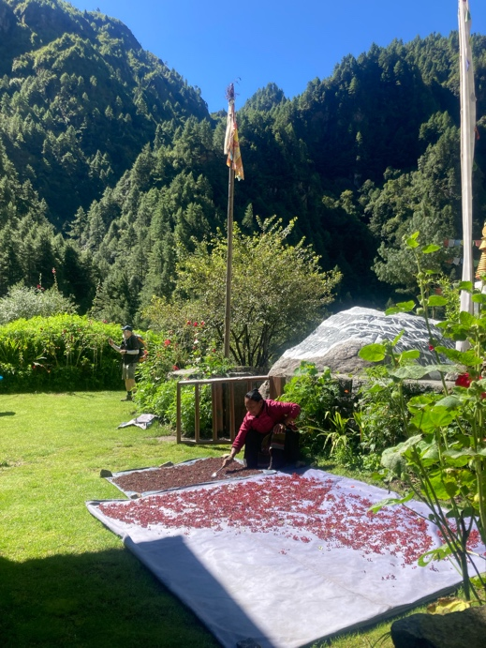

Aago aago ma pani paryo (Even in fire, there fell water).
Re-imagining disaster risk reduction projects through the centering of women.
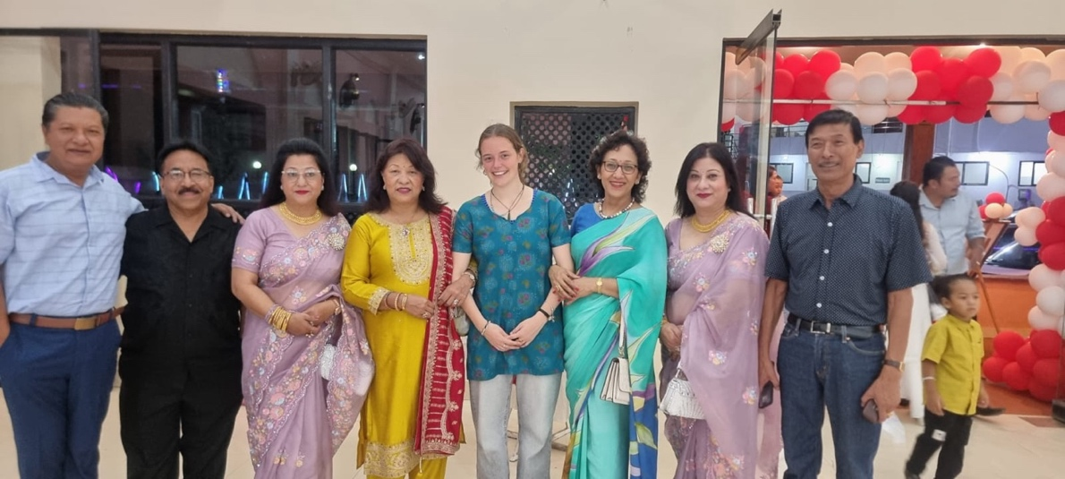

Acknowledgements
I would firstly like to thank the Durham University Expeditions Fund for giving me the life-changing opportunity to travel to Nepal to conduct this research. Without this, I would not have been able to go, and I believe it has shaped the trajectory of my future.
I would also like to thank NSET, in particular Dr Gopi Basyal, who was so kind in giving me a desk to work at in the headquarters, in helping arrange interviews and making me feel at home in Nepal.
I cannot express my gratitude to all the people in Nepal who took time out of their busy lives and schedules to be interviewed and all the humanitarian workers who lay out their lives in the pursuit of Disaster Risk Reduction.
I will forever be indebted to Sunil and Pramita Tamrakar who opened their home to me and enabled me to experience the beauty of Nepalese culture firsthand.
Last, but by no means least, I want to thank from the bottom of my heart every woman who fights every day for the right to speak and to protect herself and her loved ones from disasters. To every woman who walks hours for those meetings, every woman who gets up at the crack of dawn to look after the house and the farm, every woman who has been sidelined or marginalised for speaking up – you have been my inspiration, my encouragement, my example, my model.

Introduction
1.1. Disasters and Response in Nepal
Nepal is a country highly susceptible to a range of hazards including earthquakes, landslides and floods. It currently ranks 11th in the world in terms of earthquake risk, and 20th in terms of disasters (Oxfam Report, 2019). Recent events include the 2015 Gorkha earthquake which killed around 9,000 people in Central and Western Nepal; and the 2017 floods which killed 134 people, and displaced tens of thousands.
In response to these disasters and a global trend of ‘localization in development’, community-based disaster risk reduction (CBDRR) has become a cornerstone of development and disaster planning, promoted by donor organizations, NGOs and governments internationally (Maskrey, 2011). CBDRR is designed to respond to problems and needs by using local knowledge and expertise. In this way, it hopes to strengthen communities’ technical and organizational capacities to prepare for and respond to disasters (Wisner, 2006).
I chose to zoom in on disaster risk reduction projects, rather than development projects as a whole because, as Fothergill (1996) so aptly explains, the disaster setting is considered a ‘unique laboratory’ and ‘strategic site’ in which to learn about social phenomenon. Disasters are in fact indicative of social phenomena as they “strip away the veil” that usually obscures or disguises many social conditions (Barton, 1970; Merton, 1970). These social processes are compressed in a very dramatic, short time span.
1.2. Disasters as gendered
In this report, gender is the fundamental concept of analysis because women are generally the main stakeholders in these disaster situations. In his article, ‘Disasters are gendered: What’s new?’, Seager (2014) outlines the ways in which women are perpetually and disproportionately more affected and vulnerable in these disasters than men, as disasters and responses to them reflect and occur within socially constructed gender norms. For example, a 2008 report highlighted a mobile phone-based warning system being piloted in flood-prone Bihar, India (Arcenaux, 2008). However, this good news has to be placed against the irony of the recent implementation of local laws in Bihar which banned women rom using mobile phones. More women die, suffering the most from the impacts (Bradshaw, 2014) due to men having out-migrated and women often being indoors cooking and looking after children when disaster strikes (Petal et al, 2017). Similarly, women are sometimes physically weaker due to having less food and so unable to protect themselves (Rivers, 1982). In the case of Nepal, we see how disasters in the previous few years have exacerbated and compounded existing inequalities and vulnerabilities – the poorest being most likely to suffer death, injury and damage to property. Women and children are also 14 times more likely to die than men during a disaster (NHRC, 2017).
I agree with Jacob’s (2019) when he asserts that being a woman does not make you vulnerable, it is the systems of oppression that construct female identity that makes one vulnerable. Inequality kills women, not their biology. And despite a global mandate on gender equality in DR management (Hyogo Framework, 2005), the gap between policy and implementation is vast. The observation of these ideas is now commonplace and there is a plethora of data to show for it, so my research does not dwell on these well-documented facts.
1.3. Women in decision making spaces
My research was geared towards investigating the role that women, as some of the main stakeholders in disaster situations, play in the DRR committees and locally based projects. This is an embryonic literature in Nepal. Why this is important is because, as Nightingale (2015a: 221) argues, "It is impossible to produce durable adaptation programs without accounting for socionatures and power". Development and disaster preparedness can only go so far without attending to the social and cultural dimensions of disaster (Wisner et al, 2004). In this research, I aim to take on board the analytical lesson from feminist scholars of “lifting the roof off the household” (Seager, 2014).
Previous literature describes how CBDRR programs may tend to focus on the worth of women’s labor to the development process, assuming “women have infinite time to participate in volunteer-based community groups” (Lind, 1997: 1208), rather than seeing women themselves as actors who can bring valuable contributions to the consultation and decision-making process surrounding building resilience. Despite women’s considerable work in relief and recovery, most research finds that women are not in positions of authority (Jacob’s, 2019; Noel, 1998; Khondker, 1996). We see how their interests are often marginalized or overlooked in apparently “participatory” processes (Mayoux, 1995; Mosse, 1995). Rather than treating women as mere “victims of their culture" (Cupples, 2007: 156), it is essential to recognize the ways that they have "agency, special contributions and capacities" (Wisner, Berger and Gaillard, 2017: 27).
Cornwall (2003) also emphasizes the difference between nominal, instrumental and transformative participation and argues that increasing the numbers of women involved in projects may serve instrumental goals but will not necessarily address more fundamental issues of power. Women may be simply delivering a version of development envisioned by more powerful others, rather than shaping local agendas (Alice Chadwick El-Ali, 2021).
1.4. Intersectionality
Nepal is an extremely interesting case study due to its unique geographical, historical, social and political context. The broad theories and presumptions that academic literature make about South Asia do not seem to quite apply to Nepal, and much data is almost outdated by the time it is published due to the ever-changing nature of the political atmosphere at the moment. For example, whilst Pant and Standing (2011) contend that there is comparatively little representation by women in decision-making at either household or at community level, through local government or NGOs, in Nepal by law, 33% of decision-making positions now have to be held by females.
What came up in my research time and time again was the importance of not simplifying my category to purely ‘female representation’ as I saw the intersectionality between gender, caste and ethnicity play a key role – some women are proportionately more represented and have louder voices than others (Phillips, 1991). Enarson (2006) calls for a recognition of the significant differences among and between women in different social locations. It is difficult to generalize gendered experiences, as there are marked differences depending upon geographical region, ethnic background, as well as caste and class rankings (Tamang 2002).
1.5. A Feminist Political Ecology Framework
Enarson and Phillips argue that disaster sociology and feminist theories work well together and should forge an even closer relationship as they use similar concepts (e.g., social power, privilege, domination, vulnerability, empowerment, political economy, and social change) and equally embrace global, interdisciplinary, and practice-oriented inquiry with libratory intent. In light of this, throughout my research and discussion, I have employed a theory of feminist political ecology, in order to provide a comprehensive framework for understanding women’s participation in CBDRR projects in Nepal.
Feminist Political Ecology directs attention towards gendered processes within the politics of the environment (Elmhirst, 2015). It emphasizes women’s practical environmental knowledge and the nexus of gender inequalities, environmental degradation, and disaster vulnerability (Rocheleau, Thomas-Slayter, & Wangarai, 1996). Of central interest to me are the gender dimensions of struggles over disasters and how these might intersect and be informed by feminist objectives, strategies and practices. There is much potential offered by FPE to further the wider transformative potential of feminism in gender and development studies.
Methodology
2.1. Feminist Methodological Approach
According to Mies (1993), there is an affinity between feminism and qualitative research in that it allows women's voices to be heard, and they are not treated as objects to be controlled by technical procedures. I believe that this idea can be extrapolated to encompass race and class as well. I chose to do interviews because I wanted Nepali voices (particularly women’s) to be heard, and I wanted to work against a Development logic that prioritizes and privileges technical procedures and results.
2.2. Focus groups and semi-structure interviews
2.2.1. Sampling and Format
I spent a month in Nepal (7th August – 7Th September) and whilst I was there I interviewed various people from the Nepali Society for Earthquake Technology (NSET), Nepal Unites, the Centre for Disaster Management Studies (CDMS), Dan Church Aid, the International Development Enterprise (IDE), Action Aid, the Disaster Preparedness Network, the NGO Federation of Nepal, Practical Action, TEWA, CARE Nepal, the Sustainable Development Solutions Network, Save the Children and the Association of International NGOs (AIN). Participants included both men and women, local NGO employees, International NGO corporations, staff members, managers, women who were part of the CBDRR projects, and people of all age groups. In the pursuit of anonymity, I am unable to give the names or roles of the participants explicitly. I also attended the Nepal Humanitarian Conference, which was held in Kathmandu to mark World Humanitarian Day, focusing on disaster risk reduction with the theme “Strengthening Global Solidarity and Empowering Local Communities.” Delegates from Bangladesh, Pakistan, Afghanistan, Fiji, India and other countries were all brought together and I had the wonderful opportunity to talk to them about how my research would translate onto other countries. Overall, I attended 2 conferences, conducted 17 interviews and held 3 female-only focus groups (3-6 people). These tended to last anywhere between 45 minutes to an hour and a half. In the end, I was unable to go out of the Kathmandu valley as a couple of the projects I had planned to go and look at were unreachable due to monsoon rains and landslides. Nevertheless, I was able to talk to some women involved in the projects who were in Kathmandu.
During my time there, I rode motorbikes or walked all around the Kathmandu Valley interviewing people – from NGO headquarters to hotel restaurants, to conference rooms, to cafes, to homes. Having conducted interviews before in the UK, I thought it would be a case of setting aside an hour or so, asking some questions in a structured manner, getting some replies and then leaving. However, an interview in Nepal looks very different – it requires a pre-existing, working relationship. I would arrive, have a cup of tea, hear about someone’s life and their families and the village in which they grew up. We would then start talking about me, then have some food and eventually get onto interview questions. Thus, an interview could take at least a whole morning if not the entire day.
2.2.2. Rationale
I believe that interviews lead to rich, detailed conversations characterized by reciprocity and a lack of a hierarchical relationship (Kelly et al, 1994). The interviews tended to be very much participant led which was a conscious choice to enable the interviewees to talk about things that were important to them and bring up topics of conversation and nuances I might not have thought of. For example, the geographical differentiation of experiences and opinions depending on whether participants were from the mountains, the valleys or the Terai region significantly dictated their ideas and thoughts about women in DRR projects. This was a fact I was completely ignorant of going in.
These interviews offered me an understanding of women’s and NGO’s opinions and experiences and ideas through their own interpretations (Bryan, 2012). Kwan (2002) advocates for the use of multiple methods to compensate any weaknesses of one method and thus increase validity. Consequently, I conducted an ethnography of a couple of CBDRR meetings. This allowed me to explore the lived experience of participants through embodiment (Powis, 2020) to get insight into taken for granted feelings and retrospective fallacies. However, for the purpose of this report I will be limiting my discussion and drawing results from my interview findings only.
Throughout, I worked to make my questions understandable to avoid putting participants off (Parfitt, 2005). For example, one of my questions was ‘What are the perceived barriers to transformative, meaningful participation in decision-making spaces that women experience?’. In retrospect, this is quite a geographical turn of phrase, using language that only appears natural to me having done almost three years of reading geography articles. Participants found it hard to interpret this, so I had to rephrase and break down the question.
For the focus groups, I anticipated that my research subject is personal and political in the context I was in, and so my group sizes reflected Morgan’s (1998a) recommendation for small groups when participants are likely to have a lot to say on a research topic. Whilst most respondents automatically agreed with what was being said, it allowed opportunities for women to probe each other’s reasons for holding a certain view and thus show contradictory viewpoints held within the same group identity. In deciding to conduct female focus groups, I hoped to constitute an opportunity for women to ‘empower themselves by making sense of their experience of vulnerability and subjugation’ (Madriz, 2000: 843). Upon reflection, considering the body language of the participants and their internal interactions (e.g. the women who were more or less vocal) could have been a fruitful line to follow.
2.3.3. Analysis
My coding of interviews proffered various themes, patterns and concepts (Charmaz, 1983), which were built on throughout the month. I used a grounded theory approach (Glaser & Strauss, 1967), in which data is treated as potential indicators of concepts rather than pre-existing theories narrating what data was collected, which aided reflexivity. An issue with this was the lack of effective inter-researcher reliability as all the coding was done by myself which may have led to subjectivity.

2.3. Methodological Issues
Aside from the electricity cuts, the lack of responses to emails, and the 3-hour walks in monsoon rains to reach people, I encountered three main methodological issues at the heart of my research. Firstly, my choices of questions and interpretations of answers reflected my own bias and positionality as a female, young, white student from the UK making assertions about a culture, behaviours, and opinions that I was only privy to for a month. I am the first to admit that I cannot and will never fully understand the area-specific dangers and experiences and barriers and opportunities that women who live in Nepal encounter. Frankly, it was difficult to suspend my own awareness of relevant theories (Bulmer, 1979) – be that a Western paradigm of development, or a feminist lens. I tried to overcome this by approaching my research with open-mindedness and a readiness for reflexivity. Therefore, whilst my research was informed by a liberal feminist framework, I constantly reminded myself that it was not within my remit to directly contest participants’ perceptions; rather, my role wass to interpret and represent their lived experiences with respect (Kelly et al., 1994).
Secondly, a few times I encountered problems in the form of a language barrier – whether that be participants not understanding what I was asking or them not having quite the right words to explain or express something. This is a limitation which I am aware will have changed and altered my findings and conclusions slightly. I overcame this through the use of translators, and I also embraced a reflexive approach in which I changed my questions slightly or elaborated on them according to necessity. Interestingly, in social research we are taught the value of making questions short and concise. I found having done that, that Nepali culture does not operate in quite this way. If I asked a quick, simple question, participants would sometimes be slightly brought up short by the fact that I had not elaborated. To encourage engagement and discussion, I therefore tailored my questions to be slightly more expansive. Also, asking the same question with slightly different emphasis or direction allowed me to uncover things that might not have been mentioned originally.
Thirdly, the nature of organizing interviews in Nepal and my research meant that participants were very aware of my questions and the aims and title of my research before I talked to them. In order to get people to agree to be interviewed, I would sometimes have to send through my full research proposal and questions, so they knew what they were saying yes to. In consequence, I actually had some NGOs and women stop contacting me when they found out what my research was on. I also had men in the organizations immediately refer me to their female colleagues which in and of itself speaks into my research. This might have led to people telling me what they thought I wanted to hear rather than the truth. It was really highlighted to me that whilst interviews give access to conscious and constructed opinions, we are presented with what the interviewee wants to present us with; they do not enable us insight into unconscious beliefs or practices or the fashioning of opinions.
Discussion: Investigating how, by centering women’s participation in CBDRR projects in Nepal, we may come to alternative imaginations of disaster risk reduction.
In this my analysis, I only want to touch briefly on the notion of women’s inclusion (as defined in my literature review) in CBDRR projects, attempting to avoid the risk of making my discussion a descriptive rather than analytical endeavour. Nepal is the first country in the South Asia region to have an act on disaster management and in the past few years, the issue of gender has been ingrained in all projects and documents. Gender Responsive Budgeting was introduced by the government in 2007/8 (UNIFEM 2008) and in 2015, the Constitution of Nepal was created, which grants 33% political representation to women, addressing their historical exclusion in political, economic, and social spheres. Even whilst I was out there conducting my research, Nepal elected its first female prime minister – a huge milestone in their history. Up until 2017, it was Village Development Committees (along with NGOs) who were mainly responsible for disaster risk reduction projects (Oven et al, 2019), but with their replacement by a rural municipality system, women by law came to occupy at least a third of spaces within these groups that were responsible for DRR planning. The true question is whether this move has purely favoured quantity over quality (Rai, 2019, Gender equality in Nepal: at a crossroads of theory and practice). Yes, equal rights may be ensured in a constitution, but we then need proper implementation of those provisions to balance that theoretical and practical gap of gender development. According to Oxfam’s (2019) report, progressive laws are often poorly implemented or ignored in practice. This leads me onto a discussion of women’s participation in CBDRR.
Going out to Nepal, my research question was namely, ‘What is the nature of women’s participation in CBDRR projects in Nepal?’. Using Cornwall’s (2003) framework of participation, I wanted to investigate whether when women participate in these projects, they are viewed as agents and citizens, and other aspects of their lives are improved.
And I mean, as the simple answer – yes, sometimes they have meaningful participation which changes their lives and sometimes they do not. But it was through these stories of what women’s participation looks like, that I was able to experience a shift in my thinking.
I was coming in from the perspective of how CBDRR projects can change and help women’s lives, rather than how women and their meaningful participation can change and help the projects. As a result of this realisation, I tailored my research focus accordingly - homing in on how centring women can help us to re-imagine and come to alternative understandings of community-based disaster risk reduction projects. In presenting this argument, I hope to reanimate ideas around the development and gender nexus.
During my interviews, I was told a famous Nepalese proverb by one of the participants; Aago aago ma pani paryo, which roughly translates to ‘Even in fire, there fell water’. As I wrote up this report and analysis, this saying kept coming back to me. Nepal, in so many ways, is a country beset by (predominantly metaphorical) fires. These fires take the form of earthquakes and landslides and floods and droughts. A logical line of reasoning would then be to ask, what is the water in this instance? What is the thing that saves? That puts out the fire? Even a perfunctory analysis would show that, despite best efforts, it is not always the government, or INGOs, or technological fixes. I contend instead that women often act as the water that protects against and prevents these fires. I have used this metaphor to structure my chapter titles and arguments.
In this report, I employ a feminist political ecology lens to argue that by centring women and their participation in Community Based Disaster Risk Reduction projects, we may come to alternative re-imaginations of what CBDRR can look Iike. This occurs on three counts:
- By centring women, we can overturn dominant narratives of vulnerability and victimhood to reimagine the communities in disaster risk reduction as having agency and power.
- By centring women, we may come to realise the original and vital contributions and perspectives that they bring to DRR projects. In this way we can re-imagine projects, or even build whole new projects, listening to other voices.
- By centring women, we come to a fuller understanding and realisation of the ways in which women are not a homogenous category, but instead vary by age, location, caste, ethnicity and personality. We can extrapolate this further to re-imagine disaster risk reduction projects as opportunities to include people from all walks of life.
Women as water, not logs: overturning narratives of vulnerability
Bankoff (2001) contends that vulnerability discourse – especially as used in disaster and development studies - is a Western construct. It is not a neutral, universal analytical tool but is instead shaped by Western historical experience, political interests and cultural assumptions. It is used to position the Global South as inherently weak/ deficient, as chronically incapable and thus reproduces a neocolonialist way of thinking the world. This discourse does not simply describe, it actively produces a way of seeing ‘developing’ nations. We justify our intervention, management and surveillance by designating certain populations or people groups as ‘at risk’ to obscure our own responsibilities. When we characterize these people as weak and passive and vulnerable (Hutcheon and Lashewicz, 2014), we locate the fault within them rather than the way the world treats them (Jacobs, 2019). During my pre-reading and in my fieldwork, I observed this dynamic directly: female participants of CBDRR projects being frequently described as ‘victims’ and ‘recipients’. Used uncritically, this approach has resonances with Fordham’s (2004) contention of the overemphasis on women’s dependency. Considering women as ‘vulnerable’ in part risks associating women with traditional ideas of femininity, weakness and dependency (Cunniff Gilson, 2016). It victimises women, making claims for their need of protection by actors outside of the women themselves (paternalism) (D’Cruze & Rao, 2004).
Women do indeed encounter many barriers to participation in CBDRR, in the form of their triple role (Oven et al, 2019): reproductive labour, productive labour and community labour, and the fact that they form the backbone of the agrarian workforce (Sugden et al, 2014). As one woman described: “Sometimes the municipalities are calling the meeting at 7am. Males can just wake up and be there. As a woman, we have to complete all household work and then go. So how we can compete?”. Particularly during the rainy season, when agricultural demands peak, attending DRR training and meetings can be extremely difficult.
However, I want to argue that an overly voracious emphasis on these barriers may characterise women as mere victims of their circumstances and thus simply reproduce pre-existing hierarchies of power. What does it look like to focus on the ways that women DO overcome these barriers?
In conducting my research, what I found was not women who were weak and vulnerable and feeble and passive. Instead, I met some of the strongest, most resilient, tenacious, adaptable, irrepressible women I have ever encountered. One NGO worker I talked to described a scenario in which she saw a woman chasing her husband down the street with a broom, yelling at him for spending too much time drinking with his friends. THESE are the sorts of characters which often make up that 33% of women. They are not sitting at home waiting for a disaster to happen (not logs ready to catch on fire, if we extend the metaphor of the proverb), rather in their own small ways – be that through the women’s solidarity movements I talked to, or getting up at 4am everyday, or walking 5 hours to attend a meeting – they are disproving much that is assumed about their vulnerabilities. In the style of Faulkner (2018), who uses a feminist analytical approach to privilege the voices of her participants, I have composed a poem out of some of the responses I received. In this way, I hope to use poetry as a megaphone of women’s voices.
You just can’t imagine how powerful they are
I come from Mt Everest
I come walking four hours
I come to meet you

I am powerful
I am a conqueror
I am the backbone

We have many things on our heads
We are resilient
We learn
We see through this the ways in which Nepalese women challenge the conventional associations of action with masculinity and passivity with femininity as described in Butler et al’s (2016) work. By attending to and centering the real, on-the-ground lives of women in CBDRR projects, we are able to de-naturalise and de-essentialise our notions of vulnerability. Feminist Political Ecology teaches us that disasters are not natural events, but phenomena produced through power-laden interactions between humans, environments, and institutions. We must therefore interrogate how notions of vulnerability are made and maintained. FPE can help us re-centre the analysis: women are not inherently vulnerable; they are positioned within political and ecological systems that render them more or less secure.
It would be a grave mistake to neglect the nuance of this conversation. The strength and determination of these women do not negate the barriers and difficulties and awful situations they encounter in their day-to-day lives. We also cannot expect to put responsibility on them just because they are so resilient and capable – this would further entrench ideas of individualising responsibility for self-securitisation in the name of empowerment and thus provide more of an excuse for government’s neglect of marginalised citizens (Gladfelter, 2018). It is essential to pinpoint the places where real vulnerability does exist. However, I do argue that we must go beyond a victim model to re-imagine DRR projects as spaces where the capacities of women can and should be recognized and utilised.
Fire needs fresh water, not stagnant ponds: the original contributions of women for disaster risk reduction
Previous research on risk communication concludes that men and women do not hear, interpret, or personalise disaster warnings in the same ways (Fothergill, 1996). Building on this foundation, I argue that women bring important, genuine and original contributions to CBDRR projects. My research in Nepal found that women’s skills and perspectives significantly strengthen disaster response and preparedness in ways that may be overlooked by formal DRR systems. This occurs on four counts.
Firstly, women’s detail-oriented and localised perspectives provide insights that male community members often overlook. Women possess a deep awareness of everyday, household-level concerns that shape the lived experience of disaster risk. One evaluator observed that men tend to offer abstract or generalised descriptions of preparedness, whereas women provide grounded, practical accounts centred on food security, childcare, and family well-being:
- “If you go and ask if there is a father and mother, then the men and women in the household, if you ask the husband or male of that family about what's your preparedness within your family, he will talk blah blah blah, very big, big thing. But if you go and ask the women, they will give you practical things. Like more about food and kids. Kids, everything.”
This difference becomes especially apparent in planning: while men were seen to prioritise infrastructure solutions such as river training or electricity for the whole village, women emphasised torches needed at night, children’s safety, breastfeeding facilities, and the need for separate toilets in displacement camps. For example, in one project that was run, a lot of money was being diverted into sanitary packs for menstruating women. However, the local women involved in the projects came together to share that in their village, there were only a few menstruating women as most of the females were either pregnant or too young/ old for their periods. In consequence, the money was redirected towards buying bedding to sleep on in the shelters. This is a great example of those small, detail-oriented approaches that change the way projects may be run, and money may be spent – contributing to longer term safety and comfort for all those involved. Their attention to smaller household need meaningfully enriches the planning process and strengthens the thought process behind DRR interventions.
Secondly, women contribute through their social networks. Turner et al. (1979) demonstrated that women are more likely to receive and share risk information due to the social ties they maintain. My findings strongly support this in the Nepali context. Women often act as central connectors, embedded into the social fabric of their villages, enabling information to move quickly, accurately, and with cultural nuance. Due to their triple role, they are intimately a part of the everyday goings on in their neighbourhoods and learn from, teach, confide in and challenge each other. One project evaluator described this vividly: “She has seen the community. She knows who is who. And she knows how to tweak. She knows the contacts—who to ‘attack’ and when. ‘Attack’ in the sense of: okay, give it to me, otherwise I can do this. Their ability to negotiate also strengthens.” Women are positioned as messengers and negotiators within community life. Interestingly as well, women’s leadership was also associated with lower corruption: “If the women are there, the service providing is better… corruption is less than men. Not zero, but lower.” This may have hugely beneficial consequences for CBDRR projects because women can bring in that localised, grounded, less biased perspective.
Thirdly, women bring pre-existing skill sets that are directly transferable to disaster management. Noel (1990) argues that the technological and managerial skills women use in domestic life can be powerfully applied to risk reduction. From my interviews, it became clear that these include an ability to learn very fast (e.g. masonry skills, new languages), efficient organisation, meeting management, practical knowledge (One participant remarked how “I was surprised to see how the women talked about the risks within their own households—floods, landslides—and how they were mitigating and preparing.”) and a plethora of other skills that are essential in CBDRR projects. And if we do indeed invest in these pre-existing skills that women possess, “they benefit the larger community, not only themselves.”. Yet these competencies are frequently under-utilised within formal DRR structures. I want to argue that we must centre women and learn from their management skills in order to get the best disaster risk reduction in Nepal that we are able.
Fourthly, women draw on generations of inherited knowledge that long predates the arrival of INGOs and CBDRR frameworks. Many women already have a sophisticated understanding of resource management and household preparedness strategies in the face of disasters. As one participant reflected, “Being educated is easy, being wise is hard.” It is essential not to disregard an already deep well of existing knowledge or assume that projects are “teaching” local communities all they know about disasters. For example, before the monsoon and the consequent floods, women traditionally ensured rice was dried and stored months in advance; a wonderful example of a soft approach to preparing for disasters. One woman in a project I talked to said,
- “Nowadays, every year-round we can find the vegetable even in the rural area. People are bringing from here, but earlier days it was in the monsoon season it was very difficult to get the fresh vegetable. Then they used to make dry vegetable. They used to dry it to prepare like cucumber, mushroom type of different and then keeping for this monsoon. That's the preparedness. Then earlier days no gas, no heater. They used to firewood. They used to make like chop this firewood and making like a big stockpile. They are keeping for the 4-5 months and using that. That's the preparedness.”
Such practices illustrate a long-standing culture of preparedness transmitted through the maternal line. As disaster risk grows and development funds shrink—exemplified by the recent US AID cuts—it is more crucial than ever to recognise and build upon these embedded systems of knowledge rather than sidelining them.
In light of these findings, it becomes clear that excluding women from CBDRR weakens the sustainability, ownership, and wisdom of disaster interventions. In fact, as one practitioner put it, “development gains become siloed.”. If disaster risk reduction is to be transformative rather than tokenistic, it must draw on the “fresh water” of women’s wisdom, experience, and innovation—not remain dependent on the “stagnant ponds” of outdated, top-down approaches. Whilst hearing these other voices “may take double the time and slow down the processes”, the cost of overlooking women’s contributions is far greater. Crucially, the absence of women’s perspectives in DRR is not merely an issue of process—it has life-and-death consequences. In saying all this, it is essential to acknowledge that engaging women cannot occur in isolation. As one participant emphasised, “Without engaging men, we are not going to be successful. We need to convince men. Once men are convinced, it’s easy to convince others.” Effective CBDRR projects require communication and support across social groups, shared understanding of legal rights and protections, and collective awareness-raising that includes but does not overburden women.
Water comes in lots of different forms: Remembering intersectionality
When women are placed at the centre of CBDRR projects, it becomes immediately clear that “women” are not a homogeneous group. Their experiences and perspectives vary widely according to age, caste, income, ethnicity, geographical location, family structure, personality, and life history. There are always multiple, overlapping identities which construct how participation is experienced in CBDRR projects. For example, a rich woman is four times more likely to have gone to school than a poor woman, while a rich man is fifty times more likely (DHS Survey, 2016). This diversity shapes how they perceive risks, how they communicate within their communities, and how they are able—or unable—to participate meaningfully in disaster governance. Recognising this variation is essential, because poorer women, or lower caste men, in low-income countries often face profound obstacles to receiving not just equitable relief, but a say in the processes of DRR management.
My research in Nepal undeniably revealed such nuances. Every single interview I conducted, this issue of intersectionality was raised. One woman described how women are very much involved in the CBDRR projects in the mountains, with men having out-migrated, they are the ones running the meetings, making the decisions and helping to implement the projects. Before their involvement, “they were afraid of talking outside but now they have become like leaders and, you know, they are so forthcoming now outside in the society. They have changed their personality. They have changed their thinking. They have changed their attitude. And so, you know, they are involved in so many other activities because of this disaster itself.” Conversely, “In Terai, even the deputy mayor was coming to the office with her husband. She was just listening, and the husband was talking on her behalf.” Despite positional authority, women due to their caste, remain constrained in practice. Here, women’s participation is socially discouraged: “we could not invite them to our training because if somebody goes to participate, they become a kind of member for the jokes.”. We see how local women’s voices may be strong in the hills but less audible in urban or western regions (“What may suit Kathmandu may not suit the Far West.”).
In other cases, personality and confidence shape participation as much as gender norms: “Some of the women are the kind of persons—just like some men—who think: okay, I’m at this level, which means I know everything.”
These examples reinforce the idea that gender alone cannot explain the complexities of participation and meaningful involvement. As one stakeholder put it, “You can’t generalise the whole of Nepalese women in one basket and then say yes or no.” Social dynamics vary widely even within short distances – a fact that may be true of other countries, but is particularly cogent in the case of Nepal, with its complex geographical, cultural, and religious make up. This was exemplified through one participant’s explanation that “If you go in one community, maybe that community trusts their own people more than strangers. In another, they will listen more to strangers than to their own people. You have to be connected. Context analysis is very important.” These variations highlight why a single model of “women’s participation” cannot be assumed to work everywhere.
For these reasons, “women’s participation” cannot be treated as a catch-all phrase, nor as a guarantee of improved CBDRR outcomes. To attempt to reduce women’s experiences into something universal and easily comprehensible—as Bohler-Muller (2012) warns—would be a disservice not only to women but to all marginalised groups. Simply adding a female voice does not magically fix a project. In some contexts, a Dalit man may be far more marginalised than a high-caste woman; in others, caste or disability may outweigh gender altogether. Intersectionality, therefore, is not an optional add-on but a fundamental lens through which effective CBDRR must be designed.
Ultimately, these findings underscore the immense importance of rigorous, locally grounded context analysis. Only by understanding the layered identities and social structures that shape people’s risks and capacities can CBDRR projects become equitable, culturally appropriate, and genuinely transformative.
Conclusion
In conclusion, I argue that by centring women and their participation in Community Based Disaster Risk Reduction projects, we may come to alternative re-imaginations of how these projects can be envisioned and practiced. Firstly, we can overturn dominant narratives of vulnerability and victimhood commonly attributed to women, to reimagine the communities in disaster risk reduction as having agency and power. Secondly, by centring women, we may come to realise the original and vital contributions and perspectives that they bring to DRR projects. In this way we can re-imagine projects, or even build whole new projects, listening to other voices. And lastly, we can re-imagine CBDRR projects as made up of heterogeneous people, varying by age, location, caste, ethnicity and personality. This research contributes to current theories of feminist political ecology which dials in on the relationship between women and their environments to show how women’s participation may be a pivotal moment and opportunity to better understand how to respond to disasters, and in so doing, save lives.

References
Adger, W. N. (2000) ‘Social and ecological resilience: are they related?’, Progress in Human Geography, 24(3), pp. 347–364.

Allen, K. M. (2006) ‘Community-based disaster preparedness and climate adaptation: Local capacity-building in the Philippines’, Disasters, 30(1), pp. 81–101.

Allendorf, K. (2007) ‘Do women’s land rights promote empowerment and child health in Nepal?’, World Development, 35(11), pp. 1975–1988.

Bradshaw, S. (2013) Gender, Development and Disasters. Northampton: Edward Elgar.
Chadwick El Ali, A. (2021) Southern expertise in volunteering for development is vital for transformational change.

Cupples, J. (2007) ‘Gender and Hurricane Mitch: Reconstructing subjectivities after disaster’, Disasters: The Journal of Disaster Studies, Policy and Management, 31(2), pp. 155–175.

Delica-Willison, Z. and Gaillard, J. C. (2012) ‘Community action and disaster’, in Wisner, B., Gaillard, J. C., and Kelman, I. (eds.) Handbook of Hazards and Disaster Risk Reduction. London: Routledge.

Elmhirst, R. (2015) ‘Feminist political ecology’, in Perreault, T., Bridge, G. & McCarthy, J. (eds.) The Routledge Handbook of Political Ecology. Abingdon / New York: Routledge, pp. 519–530.

Enarson, Fothergill and Peek (2018) Gender and disaster: foundations and directions for research and practice. In Rodriguez, H., Donner, W. and Trainor, J.E. (Eds.) Handbook of Disaster Research. New York: Springer: 205-223.

Fothergill (1996), The neglect of gender in disaster work, International Jornal of Mass Emergencies & Disasters 14(1)33-56

Gender Equality (2017) Nepal Flood Response 2017: Gender Equality Update No. 12. Available at: https://reliefweb.int/sites/reliefweb.int/files/resources/Gender%20Equality%20Update%20No%2012%20%2831%20August%202017%29%20Final%20version.pdf.

Gladfelter, S. (2018) ‘The politics of participation in community-based early warning systems: Building resilience or precarity through local roles in disseminating disaster information?’, International Journal of Disaster Risk Reduction, 30(Part A), pp. 120–131.

Jacobs (2019) Black feminist and radical planning: new directions for disaster planning research. Planning Theory 18(1): 24-39.

Jones, S., Oven, K. J., Manyena, B. and Aryal, K. (2014) ‘Governance struggles and policy processes in disaster risk reduction: A case study from Nepal’, Geoforum, 57, pp. 78–90.
Jonasdottir, A. (1988) ‘Does sex matter to democracy?’, Scandinavian Political Studies, 11(4), pp. 299–322.

Li, T. M. (2016) ‘Governing rural Indonesia: Convergence on the project system’, Critical Policy Studies, 10(1), pp. 79–94.

Lind, A. (1997) ‘Gender, development and urban social change: Women's community action in global cities’, World Development, 25(8), pp. 1205–1223.

Manuel, M., Grandi, F., Manea, S., Kirbyshire, A. and Lovell, E. (2018) ‘Leave No One Behind’ Index 2018. London: ODI. Available at: www.odi.org/sites/odi.org.uk/files/resource-documents/12304.pdf.

Maskrey, A. (2011) ‘Revisiting community-based disaster risk management’, Environmental Hazards, 10(1), pp. 42–52. doi:10.3763/ehaz.2011.0005.

Mayoux, L. (1995) ‘Beyond naivety: Women, gender inequality and participatory development’, Development and Change, 26(2), pp. 235–258.

Mueller Hirth, N. (2012) ‘If you don't count, you don't count: Monitoring and evaluation in South African NGOs’, Development and Change, 43(3), pp. 649–670.

Nightingale, A. (2015) ‘A socionature approach to adaptation: Political transition, intersectionality, and climate change programmes in Nepal’, in Inderberg, T. H., Erikson, S., O’Brien, K., and Sygna, L. (eds.) Climate Change, Adaptation and Development: Transforming Paradigms and Practices. London: Routledge, pp. 219–234.

O’Brien, K., Eriksen, S., Nygaard, L. P. and Schjolden, A. (2007) ‘Why different interpretations of vulnerability matter in climate change discourses’, Climate Policy, 7(1), pp. 73–88.

Pant, B. and Standing, K. (2011) ‘Citizenship rights and women’s roles in development in post-conflict Nepal’, Gender & Development, 19(3), pp. 409–421. doi:10.1080/13552074.2011.625656.

Petal, M., Baral, S., Giri, S., Rajbanshi, S., Gajurel, S., Paci-Green, R., Pandey, B. and Shoaf, K. (2017) Causes of Death and Injuries in the 2015 Gorkha (Nepal) Earthquake. Kathmandu: Save the Children. Available at: https://resourcecentre.savethechildren.net/sites/default/files/documents/causes_of_deaths_and_injuries_nepal_earthquake_report_eng_2017.pdf.

Phillips, A. (1991) Engendering Democracy. Pennsylvania State University Press.

Richardson, D., Laurie, N., Poudel, M. and Townsend, J. (2016) ‘Women and citizenship in post-trafficking: The case of Nepal’, The Sociological Review, 64, pp. 329–348.

Rigg, J. and Mason, L. R. (2018) ‘Five dimensions of climate change reductionism’, Nature Climate Change, 8, pp. 1027–1032.

Seager, J (2014) Disasters are gendered: What’s new? In Sinh, A. and Zomers, Z. (eds) Reducing disaster: Early warning systems for climate change. Dordrecht, Springer: 265-281.

Tamang, S. (2018) ‘Democratic deceits: Embedding the constitution and elections in arrested political and social change in post-earthquake Nepal.’ Keynote Lecture, 16th British – Nepal Academic Council Study Days, Durham University, April 16–17.
Appendix I
(1) Examining how various (I)NGOs address women’s inclusion in their CBDRR projects
- How many women are involved in your current project?
- What proportion of the Village Development Committee do they make up?
- How would you define women’s inclusion in the context of your CBDRR work?
- Do you see women’s inclusion in your project as important? Why/why not?
- On a scale of 1-7 (Likert Scale), how much is women’s inclusion a priority in your project?
- What motivates your organization to focus on women’s inclusion?
- Why/ why do you not include women in your project? What challenges do you face?
- Do you feel you have a say in increasing women’s involvement in your projects?
- How do you engage with local communities to encourgae women’s involvement?
- What strategies/policies are you using to boost female inclusion?
- Are these strategies working? Why/ why not?
- What does successful inclusion of women in CBDRR projects look like to you?
- Why do you think there are often more men on project committees?
- How has the inclusion of women in CBDRR projects changed in the last 20 years?

(2) Exploring the nature of women's voluntary participation in these initiatives.
- What sorts of roles and positions are women typically given in your project? And why are they allocated these roles?
- Do women make decisions on your committees?
- What proportion of the voluntary labor in the projects is completed by women?
- Are women involved in decision-making processes, or primarily in implementation and labor roles?
- Can you give me an example of a time when local knowledge and expertise specific to women was used in one of your projects?
- How have women’s voices shaped local agendas and projects?
- What influences your decisions around the timings and locations of CBDRR committee meetings?
- How do you make sure the worries and concerns of women in regard to disaster risk reduction are heard and addressed within projects?
- (To ask the women) ... What are your concerns, and do you feel like they are being heard?
- How do you define ‘meaningful’ or ‘transformative’ participation?
- Can you give me an example of a case of transformative participation (define for participant) of women in your projects?
- What are the perceived barriers to transformative, meaningful participation in decision-making spaces that women experience?
- How do you as an NGO negotiate/ overcome these barriers?
- How do women overcome their barriers?
- Would you say that participation in CBDRR projects affects other aspects of women’s lives?
- How do women negotiate their multiple identities as volunteers in projects, homemakers and farmers?
- Can you describe the difference between women being “present” in a project and women actively shaping it?
- How do cultural and social norms in Nepal influence women’s involvement in DRR efforts?
- What support mechanisms (e.g., training, mentorship) are provided to help women take on leadership roles in CBDRR?
- What motivates women to voluntarily participate in your projects?
- How do power dynamics within households and communities impact women’s ability to participate?
- Are there any forms of indirect coercion that influence women’s participation in these projects?

