Investigating how embodied and spatial barriers shape Māori diabetics access to diabetes related healthcare in Rotorua, New Zealand.
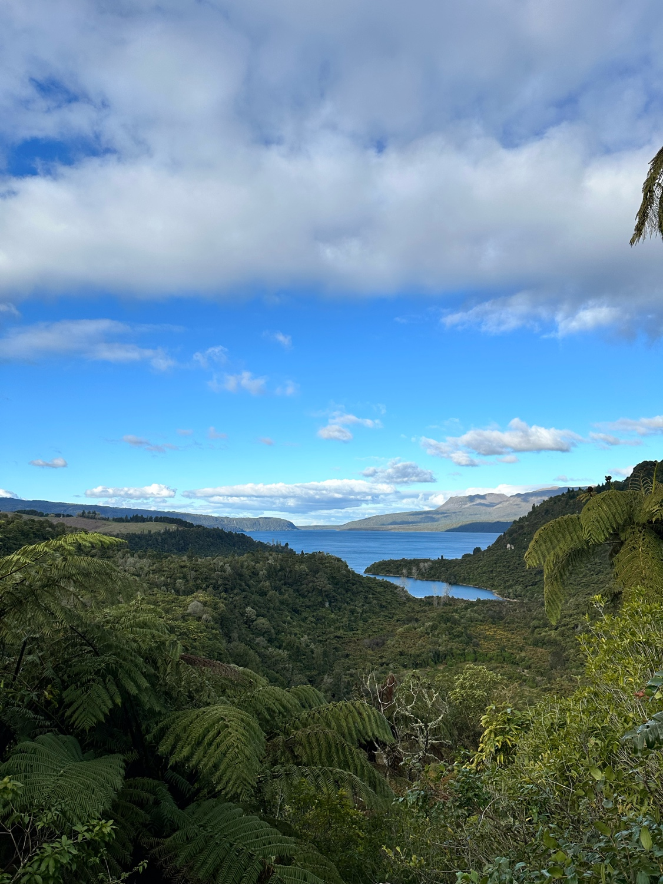


Beth du Preez

ACKNOWLEDGMENTS
I would like to thank Durham University Expedition Society for their funding and for making this experience and research possible. I would also like to thank Natasha Van der Walt and Tim Ryan for their fantastic advice, support and knowledge in Rotorua Healthcare and Rotorua Lakes Hospital. I am inspired by your commitment to stay curious and I hope to follow many of your values on in my own life.
ABSTRACT
This study investigates how we can use the scale of the body to assess how people living with diabetes in Rotorua experience and navigate healthcare access in their everyday lives. While epidemiological disparities are well recognised, especially for Māori, far less is understood about how diabetes is felt and interpreted within a post-colonial urban place. Addressing this gap the exhibition research foregrounds the body as a fascinating site pointing to wider context of nation and history, revealing the intimate geographies through which illness takes shape. I used semi-structured interviews, participant observation and body mapping methodologies. The research draws on perspectives of those with and without diabetes, healthcare professionals, community workers and patients to understand healthcare access across self-management to family networks, clinical biomedical encounters and biopsychosocial factors and models. I identify 3 interconnected themes: (1) slow violence: structural harm accumulating in the body, (2) embodied moralisation and self-surveillance, and (3) spatial imaginaries of illness. Together these insights demonstrate that diabetes in Rotorua is a lived outcome of intersecting bodily, spatial and political processes/power.

CONTENTS
ABSTRACT ............................................................................................................…… 2
INTRODUCTION ......................................................................................................…. 4 LITERATURE REVIEW .............................................................................................… 5
METHODOLOGY ....................................................................................................….. 7
RESULTS .............................................................................................................……. 8
1. SLOW VIOLENCE: STRUCTURAL HARM ACCUMULATING IN THE BODY……………….9
2. EMBODIED MORALISATION AND SELF SURVEILLANCE………………………………..10
3. SPATIAL IMAGINARIES OF ILLNESS……….................................................................12
CONCLUSION ........................................................................................................….. 13
REFERENCE LIST..................................................................................................……15
APPENDIX ...........................................................................................................……..17

INTRODUCTION The expedition fund was used to collect data for my level 3 Human Geography dissertation. This research centres on understanding the everyday experience of living with Diabetes, through the lens of healthcare access and embodied illness, specific to diabetics in Rotorua, New Zealand. Rotorua is an urban district within the Bay of Plenty. Rotorua has one of the highest Māori populations in all of New Zealand (Ministry of Health 2018) of which colonial legacy is still being addressed in New Zealand today. Therefore with my research I use the lens of post colonial theory to address Rotorua as a post-colonial society. Diabetes is particularly of interest to this research as it is disproportionally experienced by Māori to a far greater extent. There is a consistent barrier to trust and the biosocial healthcare systems as well as practical barriers to attending appointments, cost and transport within cities. While 20% of New Zealand population are Māori, 37% of diabetics are Māori, 2.5 times more likely than Pakehā (New Zealanders of European descent). Māori are more likely to develop type 2 diabetes, to be diagnosed later and to experience more severe complications. Like other non-communicable chronic disease, diabetes (especially type 2), is systematically racialised. In research scholarship far less is known about how this inequality is felt and embodied in everyday life, with limited attention to emotional and sensory experiences of Māori patients. Addressing the scale of the body as a critical site the exhibition research contributes to the intimate geographies of illness in a postcolonial urban setting. Researching the body highlights a broader multiscalar analysis of how sensory encounters connect to social and political conditions, and how history is lived out and power is contested. The research I collected included participants with and without diabetes, considering interviews from a variety of positionalities: healthcare professionals, patients in the hospital, community workers, those with type 1 and type 2 diabetes, as well as a mixture of ethnicities: Pakehā, Pacific Island and Māori. Understanding healthcare access through the lens of many participants curated a multi-scalar insight of what healthcare access can look like at many levels: personally, at a family scale, town/city, district, national and international scales. My research does not aim to offer representative account of all Māori experiences of diabetes, but focus on Rotorua as a distinctive post-colonial health landscape. I do not offer biomedical outcomes or clinical efficacy but concentrate on the experiential dimensions of healthcare access. I was particularly drawn to the scale of the body, as is reflected in my methodologies, but view the larger scales as importantly intertwined to the social, cultural and historical backdrop of the everyday diabetic. Methodologically I implored semi-structured interviews, participant observation and body mapping, foregrounding lived experience and prioritising collaborative knowledge-making (Jones, 2000). The aim of this research is to investigate how embodied and spatial barriers shape Māori diabetics access to diabetes related healthcare in Rotorua, New Zealand. The phrase ‘diabetes related healthcare’ remains comprehensive to include: managing blood sugar and complications, improving quality of life through regular monitoring, lifestyle guidance, medication management, patient education, and specialised screenings. Similarly Māori values in healthcare centre on a holistic understanding of the person prioritising manaakitanga (care), wairua (spirit), and whakapapa (genealogy). To guide this enquiry the research addresses the following research questions:
1. How do diabetics in Rotorua experience and interpret their bodies in relation to diabetes and healthcare access?
2. How do different healthcare spaces: the hospital, the home, primary care, clinics, and Marae-based services shape embodied experiences and imaginaries of illness?
3. In what ways do structural and colonial processes materialise as slow, accumulative forms of harm in the everyday management of diabetes?
Together these question frame the research commitment to examining diabetes as an everyday illness shaped through wider geographies of power.
LITERATURE REVIEW This exhibition research sits at the intersection of Indigenous health geographies, structural determinants of disease, postcolonial critiques of healthcare, and feminist embodied methodologies. Together, these literatures provide the conceptual foundations for understanding diabetes in Rotorua as an illness shaped through embodied, spatial and political processes. Scholarship in Indigenous health geographies and postcolonial wellbeing demonstrates that contemporary health inequities in New Zealand are inseparable from the enduring impacts of colonisation. Smith (2012) and Panelli and Tipa (2007) highlight how land alienation, cultural suppression, and institutional racism have historically undermined Māori wellbeing, generating unequal access to food, housing, income and healthcare systems. Cram (2014) extends this argument by showing how Western biomedical structures continue to marginalise Indigenous knowledge systems, producing unequal pathways into and through care. These thinkers collectively argue that Māori health today must be understood within colonial power relations. Public health literature on the structural determinants of disease similarly position non-communicable conditions, such as diabetes, within broader socioeconomic and political systems. Marmot (2005) describes these upstream influences as “the causes of the causes,” drawing attention to how income inequality, precarious work, inadequate transport, food insecurity and the built environment shape population-level health before illness becomes clinically visible. For Indigenous communities, these determinants are inseparable from historical deprivation and policy failures, as articulated in the Whakamaua Māori Health Action Plan (Ministry of Health, 2021). This work reframes illness not as uniquely individual, but as a result of the multiscalar social and political forces. Critical social science offers further insight through concepts of structural and slow violence. Farmer (2004) conceptualises structural violence as the cumulative, often invisible constraints produced by political and economic systems. Such constraints reduce mobility, agency, and access to care. Nixon’s (2011) notion of slow violence expands this temporally, describing harm that unfolds gradually, becomes normalised, and often escapes institutional visibility. Together, these frameworks show how chronic conditions such as diabetes emerge within histories of inequality, policy neglect and colonial governance. While structural theories explain why disparities occur, I find that feminist embodied and affective geographies bring to life how such inequalities are lived and felt. In particular Longhurst (1997) and Parr (2002) argue that bodies are not passive biological entities but sites through which power, emotion and spatial relations are continually negotiated. Clinical environments such as waiting rooms, hospital corridors and consultation spaces are imbued with atmospheres of authority, surveillance and moral judgement (Ahmed, 2004), shaping how people feel, move and express vulnerability. Similarly, Ahmed’s (2004) theorisation of “sticky emotions” is particularly relevant, suggesting that emotions adhere to bodies and places, shaping interactions long after the moment of encounter. Feminist, decolonial and participatory methodologies such as body mapping offer ways to engage with these embodied geographies. Panelli and Tipa (2007) and Jones (2000) emphasise that body mapping supports participants in expressing sensory, emotional and imaginative aspects of health that may not emerge through verbal interviews alone. Such methods foreground relationality, creativity and collaboration, enabling researchers to explore how illness is situated within broader spatial, cultural and historical contexts.
Together, these bodies of literature establish a framework through which diabetes can be understood as more than an individualised biomedical condition. They view illness and diabetes as embodied and spatialised, shaped by structural inequalities, affective atmospheres, colonial histories and cultural ways of knowing. This theoretical grounding informs my analytical approach and frames my investigation into how diabetics in Rotorua navigate and inhabit the landscapes of healthcare.
METHODOLOGY Initially the project aimed to explore Māori diabetics access to clinical healthcare, however once in Rotorua I found the participants most available to me were healthcare professionals, community workers and advocates (some of which I had been in touch with beforehand via emailing a research poster), rather than solely people with diabetes. Rather than viewing this as a limitation, I reframed the research to include these perspectives, recognising that they offer crucial insight into how responsibility and structural constraints are understood within the system itself. This shift aligns with feminist methodologies that encourage researchers to follow the “everyday labour” of institutions (Pratt & Rosner, 2012) and to remain open to the knowledge that becomes available through actual encounters rather than predetermined sampling plans. The research therefore evolved into a broader exploration of geographies of access, examining how people across different roles understand and navigate barriers to diabetes care in Rotorua. I predominantly used semi-structured interviews as seen in Figure 11 (patient profiles). This enables the participants to articulate their experiences in their own terms with room for follow-up questions and flexibility. Interviews explored themes of: transport and mobility, family responsibilities of care and family norms and narratives around health, spatial meanings of hospitals and marae, and hopes for their future in diabetes healthcare. Participants were recruited through local contacts of my family who lived in Rotorua, using snowballing sampling. While the sample is not representative of all diabetics in Rotorua, it intentionally reflects a diversity of positionalities to capture a multi scalar understanding of healthcare access. Ethical approval was obtained prior to fieldwork with the geography department, and all participants gave informed consent. As a white British university educated student I approached this project with explicit awareness of the power dynamics inherent in researching Māori communities. Following Smith (2012), I sought to work reflexively, and to do my best to honour Māori values and protocols in community spaces. This looked like being careful not to overstep with taking photos of the Marae, taking my shoes off and taking time to build a rapport with each of my participants. My own body map (Figure 10) was created alongside prticiapnts to reduce hierarchy and model this research tool of embodied reflexivity. The opportunity to practice participant observation also occurred through snowballing sampling as I was invited to attend a free healthcare clinic at Marae as well as sit in on a primary care clinic appointment for someone with diabetes. This method was particularly useful in identifying contrasts between biomedical spaces and that of the Marae which is more relational and community based. I found the experience of being there very stimulating. Drawing on Ahmed’s (2004) work on how emotions ‘stick’ to bodies and spaces, paying attention to the affective atmospheres and emotions generated in each setting, recording it in my research diary. Body mapping was held at the free marae clinic. The Parawai Marae, shown in figure 1, illustrates the communal and culturally grounded environment where body mapping and the free clinic took place. The Marae is primarily serving Māori people with space for community events and sacred room for healing. Participants had the chance to sit at my table should they wish to take part in this research. Figure 2 shows the Wharekai space where educational and clinical services, and social activities occurred side-by-side. My table for body mapping aimed to generate narrative from visual and imaginative forms of expression (Panelli & Tipa, 2007; Jones, 2000). Participants were invited to respond to prompts that I lead them through using a variety of mediums: paints, pencils, pens to express their experience in relation to a bodily outline on paper. This method enables articulation of experiences that can be difficult to express verbally. Through body mapping a distinction was illustrated by the participants between “health” (clinical metrics) and “care” (support, family, social belonging), guiding me to understand the analytical importance of the body as a site of negotiation between systems and lived realities. Data analysis involved interview transcription and thematic analysis following an iterative and inductive approach. From the transcriptions emerging themes and codes included: embodied emotion, spatial experience of healthcare environments, narratives of responsibility, structural barriers (transport, cost, time poverty), the affective atmospheres of clinical spaces, colonial legacies and systemic constraints. Themes were interpreted using the conceptual frameworks of structural violence (Farmer, 2004), slow violence (Nixon, 2011), feminist embodiment (Longhurst, 1997; Parr, 2002), and affect theory (Ahmed, 2004).
RESULTS This chapter presents the empirical findings of the research, organised into three interconnected themes that emerged through the methodology: interviews, participant observation and body mapping. These themes reflect how diabetes is lived and navigated across different bodies, spaces and institutional settings in Rotorua. While the themes are conceptually distinct, collectively they illustrate how everyday diabetic experience is shaped by structural pressures, emotional labour and the spatial politics of care.
THEME 1: SLOW VIOLENCE: STRUCTURAL HARM ACCUMULATING IN THE BODY Across interviews, participants described diabetes as a continuous bodily burden. Diabetic participants used words such as “constant,” “never over,” and “exhausting” to describe the ongoing labour of self-management. This ongoing bodily labour reflects the subtle, accumulative nature of slow violence (Nixon, 2011), where harm is not experienced as a single dramatic moment but as a steady pressure shaped by social and economic conditions. P7 (See appendix figure 11 for patient profiles) pointed towards transport, cost and time as a big concern when shaping access to healthcare, explaining that cost alone could prevent people from attending general primary care. “I work at a practice in town where we charge about $60 for an appointment… Everything is additional. So I think it’s probably the biggest barrier I see” (P7). They went on to note how access is shaped by limited public transport and clinic hours “People that don’t have cars… the public transport leaves much to be desired… and we close at five. People that work multiple jobs just can’t come in” (P7). This interview reflects on the kind of structural constraints Farmer (2004) identifies as ‘structural violence’: systems that produce preventable suffering by making care logistically difficult to access. Participants with diabetes described bodily responses to these structural constraints. One patient P11 expressed that managing appointments requires planning well in advance to secure appointment slots: “At the end of the month I’ve got to go, so I’d better make an appointment now” (P11). The system of booking onto an appointment is reflective of the colonial settler’s cultural norms of administration. The administrative norms organise care around fixed schedules. The way healthcare is accessed via appointments creates a sense of formality and monitoring in ways that differ from Māori values, and practice of relational healthcare (Cram 2014, Smith 2012). I pay attention to the body mapping data which compliment these findings. In Figure 6 (in the appendix), P20 painted a black spiral wrapping around the torso of the body representing the feeling of being ‘held back’ and unable to move. This interpretation was shared in the body mapping circle in response to Prompt 3 (Appendix Figure 12), where participants illustrated where they felt the healthcare system had let them down. Feminist embodiment scholar Longhurst (1997) argues that structural inequalities materialise as bodily sensations; the spiral drawn by P20 reflects this, capturing how systemic barriers were felt as tension, pressure, and restriction within the body. Together, these findings show that diabetes in Rotorua is lived as an embodied response to structural conditions including transport barriers, socioeconomic insecurity, and the rigid administrative norms that shape access to care. These pressures accumulate slowly yet persistently, becoming felt in the body as stress, management fatigue, and, at times, a quiet acceptance of the limits of the system. This pattern reflects the slow and often invisible nature of structural harm, where everyday logistical constraints sediment into long-term bodily and emotional consequences.
THEME 2: EMBODIED MORALISATION AND SELF SURVEILLANCE
Theme 2 captures how moral expectations surrounding diabetes are embodied at multiple scales, beginning at the personal level, extending through families, and circulating within the urban core and political context of Rotorua in New Zealand. At the personal level, participants described clinical encounters that positioned them as individually responsible for managing their diabetes. Advice often centred on behavioural change (being told to “eat better” or “be healthier”) with little acknowledgement of the structural or emotional contexts shaping daily health practices. This pattern reflects wider public health discourses that emphasise individual responsibility for lifestyle diseases (Crawford, 1980; Lupton, 1995), framing health as a moral obligation that is individualised, rather than a relational or systemic process. P11 illustrated how these dynamics produced uncertainty and self-surveillance, noting her confusion around biomedical numbers: “Do you know much about the number?” “No… it goes in one ear and out the other.” (P11). Her later account of rationing medication when unable to secure an appointment demonstrated how responsibility becomes internalised even under structural constraints: “When I realised my time was running out to just get an appointment, I started eating half a day… and the last two days I haven’t even had half one because I was out.” (P11). Feminist scholars argue that such embodied experiences of accountability reflect how neoliberal health systems discipline individuals into self-monitoring practices (Petersen & Lupton, 1996), a tension clearly present in P11’s account. At the family scale, narrative and storytelling played a central role in shaping how participants understood responsibility for illness. For example P4 described how food practices were passed across generations. For example “I was brought up for a lot of years to eat what you enjoyed… Then you’re going to bring up your own children the same way”. She understands upbringing and cultural identity as key to habits formed in making your diet. Dietary change may be best understood at a family level embeded in community practices and shared norms. Biomedical advice from doctors which encourage dietary change or discipline was interpreted as undermining core family values: “To suddenly have someone saying you can’t eat that anymore… it’s disrespecting the person and not the health.” (P4). P4 also used narrative and humour, saying “I give it in a language and portray it in a cartoon… so they enjoy what the sickness is all about” to explain diabetes to her children and grandchildren. These examples show how responsibility is generationally and relationally negotiated through story-telling and narratives in family. Relational theories of care emphasise how the meaning behind illness is shaped through everyday practices, rather than solely through clinical interaction (Mol, 2008). At a broader scale, participants located responsibility within Rotorua’s spatial and commercial environment. P3 described the city as “obesogenic,” noting how urban design and food environments shape health possibilities. This aligns with public health and urban geography literature, which argues that obesogenic environments normalise limited food access, car dependency, and reduced opportunities for physical activity (Swinburn et al., 1999). These structural features demonstrate that moralisation extends beyond the clinic: responsibility and blame become embedded in the city’s spatial and commercial logics. Community health literacy is shaped by the environments people move through, meaning narratives of responsibility operate not only at the individual level but through the wider political and material conditions of place. Body mapping further illuminated how moralisation operates across personal, familial, and urban scales. P18, a house doctor participating in the workshop, drew a figure embracing the body outline, as well as illustrating the divide between “health” (formal metrics) and “care” (ongoing relational support). Their drawing revealed how institutional pressures limit clinicians’ ability to emphasise ‘care’, reflecting that the issues with bioclinical models of healthcare is felt across the whole system, not only by patients. These reflections show that moralisation is both embodied and relational. Participants’ experiences of self- responsibility and surveillance shapes their willingness to seek care. Diabetes management therefore becomes intertwined with a politics of blame, where responsibility is individualised while the structural conditions shaping people’s capacity to care for themselves remain largely invisible.

THEME 3 - SPATIAL IMAGINARIES OF ILLNESS
This theme shows how different healthcare settings in Rotorua; hospitals primary care clinics, and marae-based services, produced distinct sensory and emotional experiences. This in turn can have a hold in shaping how diabetics imagine their illness and what the future might hold. For example I found that in the hospital, diabetes information was placed beside end-of-life magazines near the chapel, (as seen in Figure 4); quietly adding to discourse on positioning diabetes with decline, and mortality. Interestingly such spatial cues can contribute to a sense of fatalism around diabetes illness. I find Thrift’s (2008) description of “affective atmospheres,” compelling of how people’s emotional experience can be affected from spatial cues, before they can consciously articulate it. The hospital corridor (in Figure 5) reflects a space of clinical order and emotional distance. In contrast, the free clinic at the community Marae positioned healthcare information on illness within a space of everyday life: accompanied with food, in a community area and for a variety of ages. During participant observation at the marae clinic, medical volunteers explained that blood tests must be taken away from the kai (Māori for food) to avoid spiritual contamination. As Figure 3 shows, clinical checks were carried out in the Wharenui to ensure separation between blood (tapu) and food (kai). In Māori values blood is considered sacred, while kai is seen as a state of spiritual neutrality that restores balance. Keeping blood separate from food is essential for maintaining spiritual safety for the person and upholding tikanga (‘the right way’). Therefore the clinic practiced healthcare within Māori customs and practices even to a spatial level. The Marae reshaped where clinical checks and services can happen and demonstrated a holistic understanding of cultural and spiritual wellbeing as integral to the the body and healthcare. P13, a healthcare professional and community worker; emphasised how delivering healthcare services outside the hospital walls shifts the power dynamics of patients – healthcare professional. He explains that “When people aren’t seeing you in the hospital, it changes the power dynamics… They are more in charge and we are less in charge.” He described how bringing healthcare services to the home counters the unhelpful narratives in Māori imagination that those who enter hospital “don’t come out”. P13’s role as a Māori healthcare professional actively reimagines the space and model of a bio clinical healthcare model. He spoke of the importance this has in mediating trust, fear, and the willingness to engage with healthcare between Māori, and indigenous groups, and the dominant Pākeha settler society. As he explained, “It wasn’t seen as, oh, I’m going to get ill. The tests were in the community.” This form of healthcare access aligns with Indigenous health scholarship, which argues that healing is grounded cultural belonging, land-based connection, and relational modes of support (Panelli & Tipa, 2007). Body mapping further expressed how participants’ spatial imaginaries shape their understanding of health and healing. When asked in Prompt 4 to identify places in their community that felt healing, participants drew natural environments and community spaces (Appendix Figures 7, 9, and 12). These symbols emphasise familiarity, safety, and connection with society, suggesting that healing is associated with environments outside formal clinical spaces. Such embodied expressions resonate with feminist and postcolonial geographies, which highlight how wellbeing is shaped through place-based attachments, affective atmospheres, and everyday interactions with landscape and home (Anderson & Smith, 2001; Panelli & Tipa, 2007). Overall, these accounts show how the spatial environment of where healthcare happens can actively shape how participants imagine their illness, and therefore its future trajectory. Hospital space evoked imaginaries of decline and mortality; marae-based clinics generated imaginaries of lived with and embodied illness, as well as culturally grounded healing; and house-visits from a healthcare profession reshape imaginaries of cultural mistrust and individualising responsibility. Moving between these settings reveal how diabetes is lived out, not only as a medical condition, but as a spatial and emotional geography.

CONCLUSION This exhibition research set out to investigate how embodied and spatial barriers shape Māori diabetics’ access to diabetes-related healthcare in Rotorua. By combining interviews, participant observation and body mapping, the study has shown that diabetes is embodied in an everyday lived way, that is experienced in the context of broader structural issues as well as moral expectations and spatial environments. Three key insights emerged. First, structural and colonial processes materialise as slow forms of harm felt in the body through stress, fatigue, time poverty and restricted mobility. These pressures accumulate gradually yet persistently, revealing how healthcare access is constrained by transport, cost, administrative norms and institutional design. Second, moralisation operates across personal, familial and urban scales, individualising responsibility while obscuring the broader structural conditions shaping people’s capacity to care for themselves. Participants internalised these expectations through practices of self-surveillance, emotional management and anticipatory behaviour, while clinicians themselves described similar pressures shaped by the restraints of centring ‘health’ above ‘care’ in the healthcare system. Finally, the spatial environment of healthcare profoundly shaped how participants imagined their illness and its trajectory. Hospitals evoked imaginaries of decline; marae-based clinics situated illness in relational and culturally grounded forms of care; and the home created space to tend to those on the outskirts of society who are met where they are at with healthcare services. Together, these findings demonstrate that embodied and experienced diabetes care in Rotorua cannot be separated from the political, cultural and historical geographies through which Māori experience healthcare. Attending to the body as a site of knowledge reveals how illness is shaped through feelings, atmospheres, spatial arrangements and the traces of colonial legacies. While this report does not claim representativeness, it offers a more life-like and holistic account of how healthcare access is lived in a distinctive post-colonial landscape. Future research could expand this work by engaging more deeply with Māori- diabetic specific studies of embodied healthcare access. Ultimately, the exhibition research underscores the need for healthcare systems that recognise the relational, cultural and spatial dimensions of illness in order to reimagine settler-colonial forms of healthcare and wellbeing.

REFERENCE LIST
Ahmed, S. (2004). The Cultural Politics of Emotion. Edinburgh University Press.
Anderson, K. & Smith, S. (2001). Emotional geographies. Transactions of the Institute of British Geographers, 26(1), 7–10.
Barad, K. (2003). Posthumanist performativity: Toward an understanding of how matter comes to matter. Signs, 28(3), 801–831.
Came, H. & Griffith, D. (2018). Tackling racism as a “wicked” public health problem: Enabling allies in anti-racist practice. Social Science & Medicine, 199, 181–188.
Cram, F. (2014). Measuring Māori wellbeing: a commentary. MAI Journal, 3(1), 18–32.
Crawford, R. (1980). Healthism and the medicalization of everyday life. International Journal of Health Services, 10(3), 365–388.
Farmer, P. (2004). An anthropology of structural violence. Current Anthropology, 45(3), 305–325.
Jones, A. (2000). Researching the body: methodological reflections. Routledge.
Longhurst, R. (1997). (Dis)embodied geographies. Progress in Human Geography, 21(4), 486–501.
Lupton, D. (1995). The Imperative of Health: Public Health and the Regulated Body. Sage.
Marmot, M. (2005). Social determinants of health inequalities. The Lancet, 365(9464), 1099–1104.
Ministry of Health (2021). Whakamaua: Māori Health Action Plan 2020–2025. New Zealand Government.
Nixon, R. (2011). Slow Violence and the Environmentalism of the Poor. Harvard University Press.
Panelli, R. & Tipa, G. (2007). Māori environmental knowledge and the river: A body-landscape geography. Transactions of the Institute of British Geographers, 32(4), 507–520.
Parr, H. (2002). Medical geography: diagnosing the body in medical and health geography, 1999–2000. Progress in Human Geography, 26(2), 240–251.
Petersen, A. & Lupton, D. (1996). The New Public Health: Health and Self in the Age of Risk. Sage.
Swinburn, B., Egger, G. & Raza, F. (1999). Dissecting obesogenic environments. Preventive Medicine, 29(6), 563–570.
Thrift, N. (2008). Non-Representational Theory: Space, Politics, Affect. Routledge.

APPENDIX

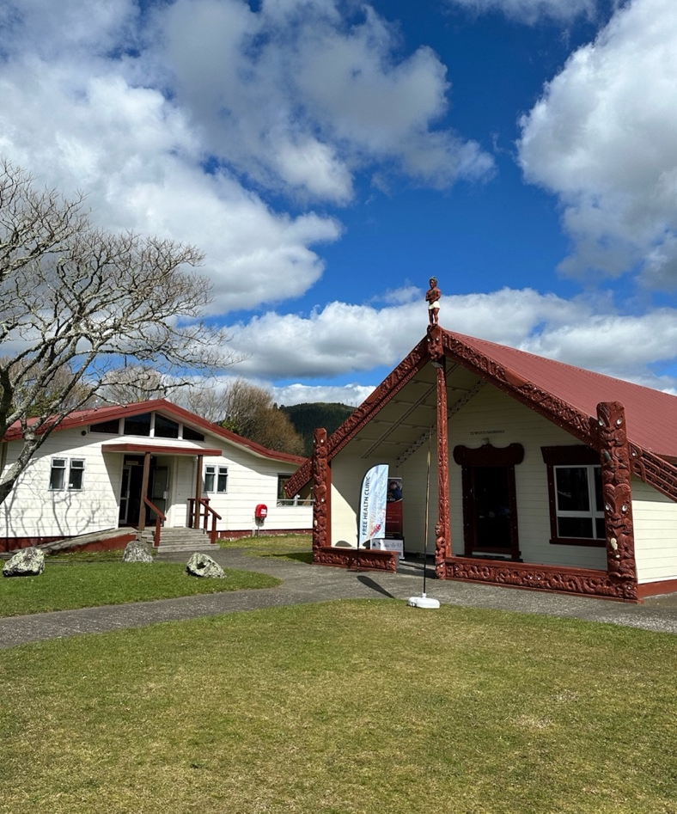
Figure 1 – Parawai Marae
Photographed Wharenui (carved meeting house), Marae ātea (an open space in front), and Wharekai (a dining hall and cooking area).

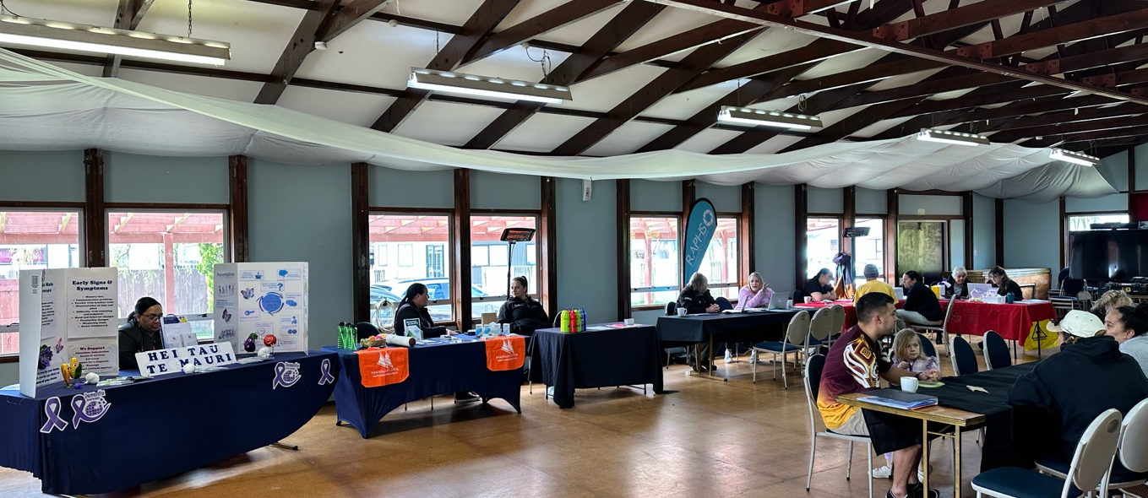
Figure 2 - Wharekai at Parawai Marae
Photograph of the tables and services offered at the free Marae clinic. Taken in the community dining hall.

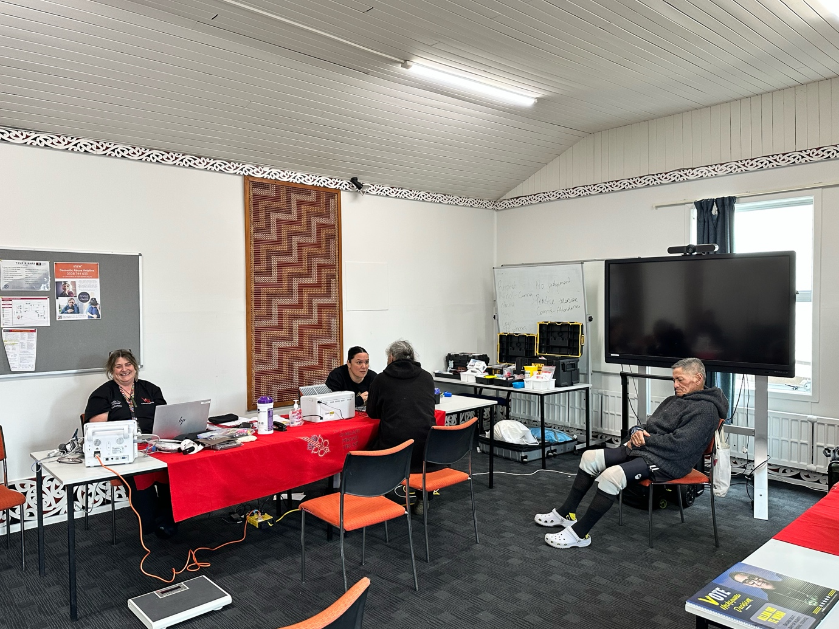
Figure 3 – Wharenui at Tarawa Pounamu Marae
Photo of free Marae clinic offering blood tests in the Wharenui as blood and food cannot be handled in the same place.

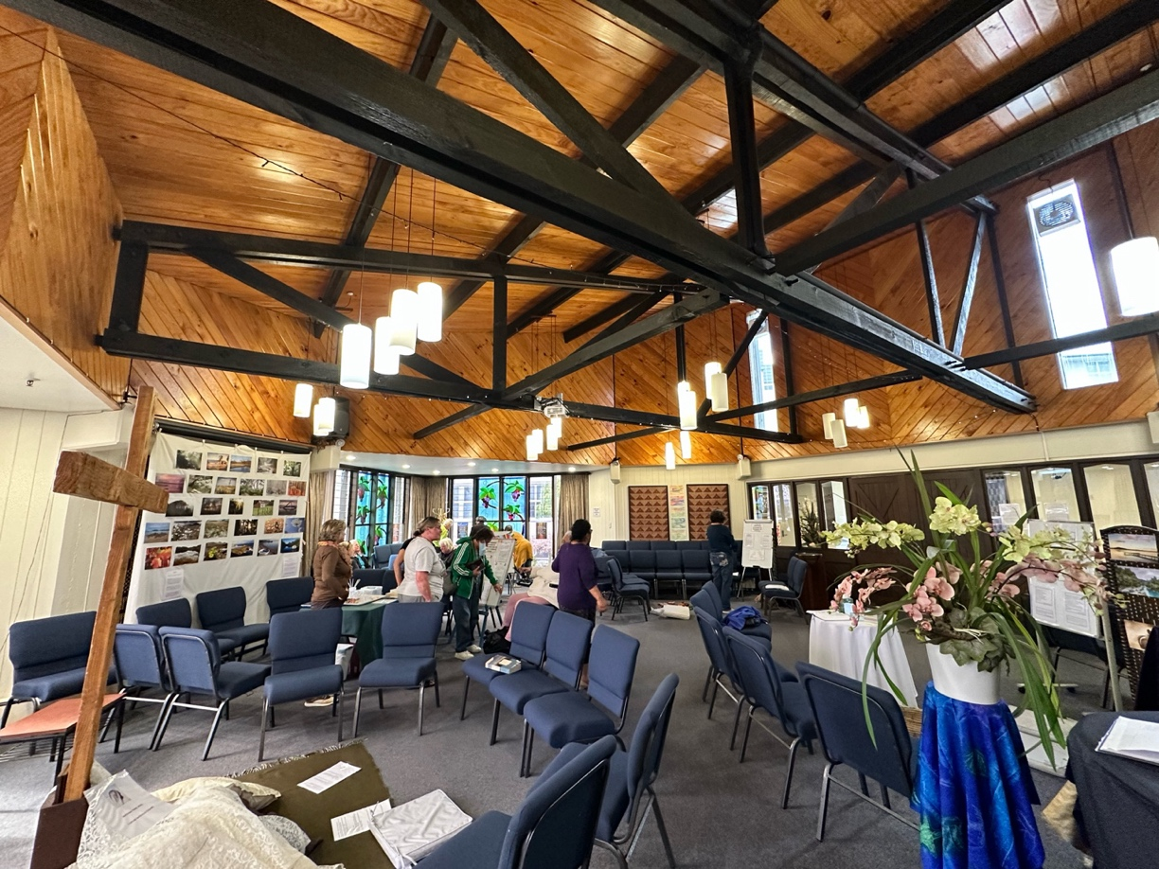

Figure 4 – Rotorua Lakes Community Hospital Chapel
Photograph includes fresh flowers, chairs and prayer activities around the chapel. A well furnished and well used, fairly large space.

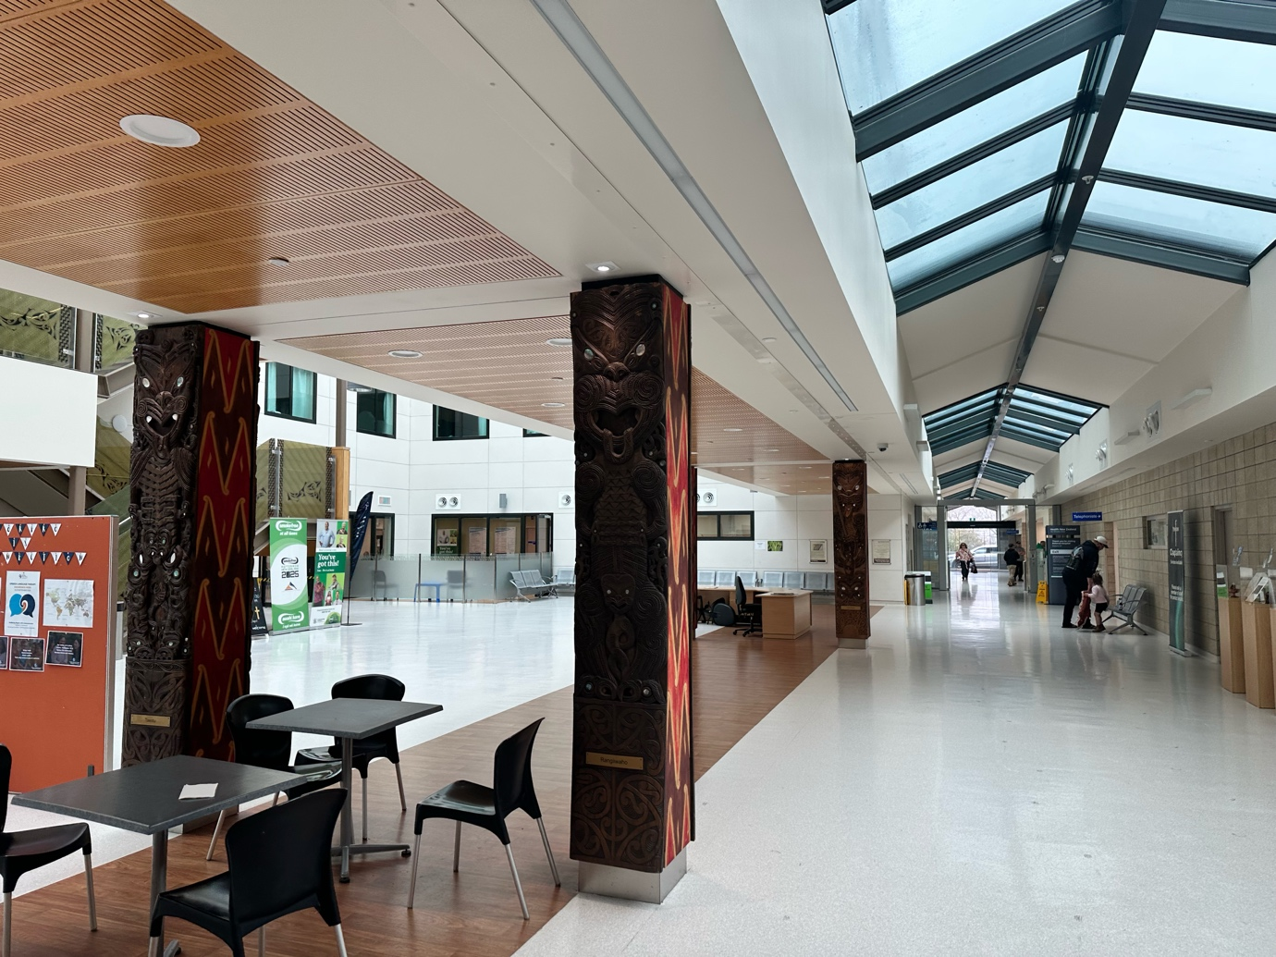

Figure 5 – Rotorua Lakes Community Hospital entrance corridor
Photograph includes well lit spacious corridor with Māori-style carved wooden pillars, and tables and chairs set out in groups.

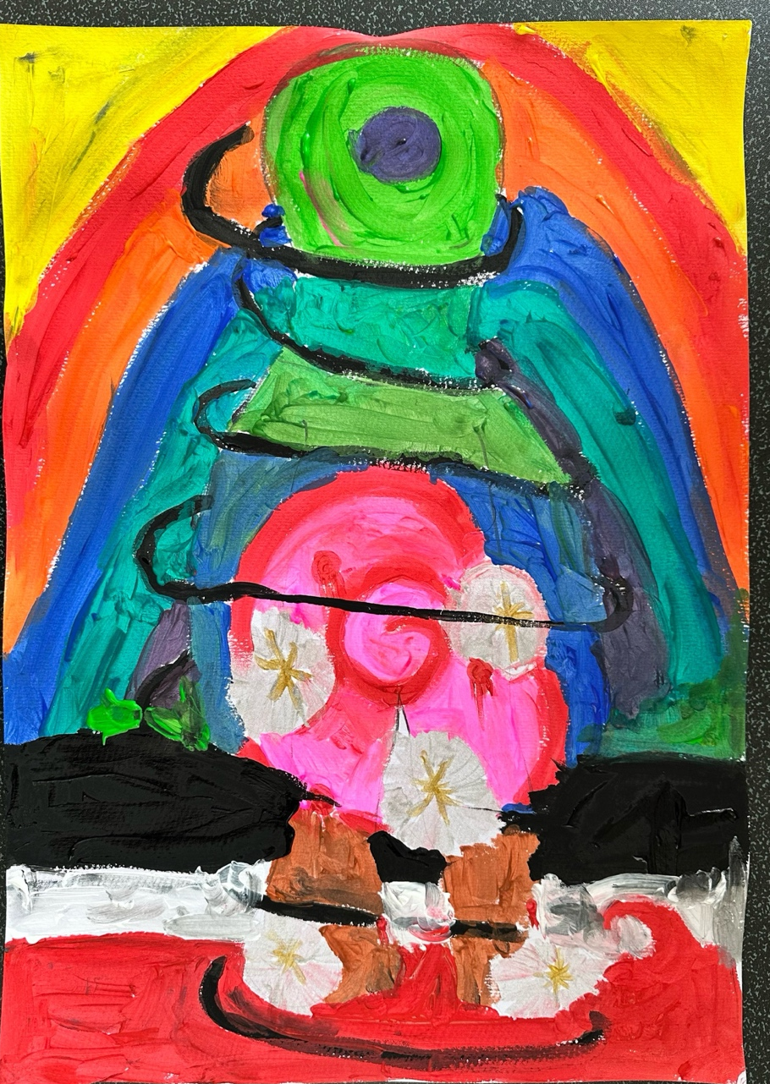

Figure 6 - P20’s body map
Photograph of A4 portrait body map. Including bright painted colours covering the whole page. The body is covered in symbols such as: black spiralling line that wraps around the body, pink and red circular swirl over the stomach and chest of the body and silver and gold spiked stars in the feet and over the stomach of the body.

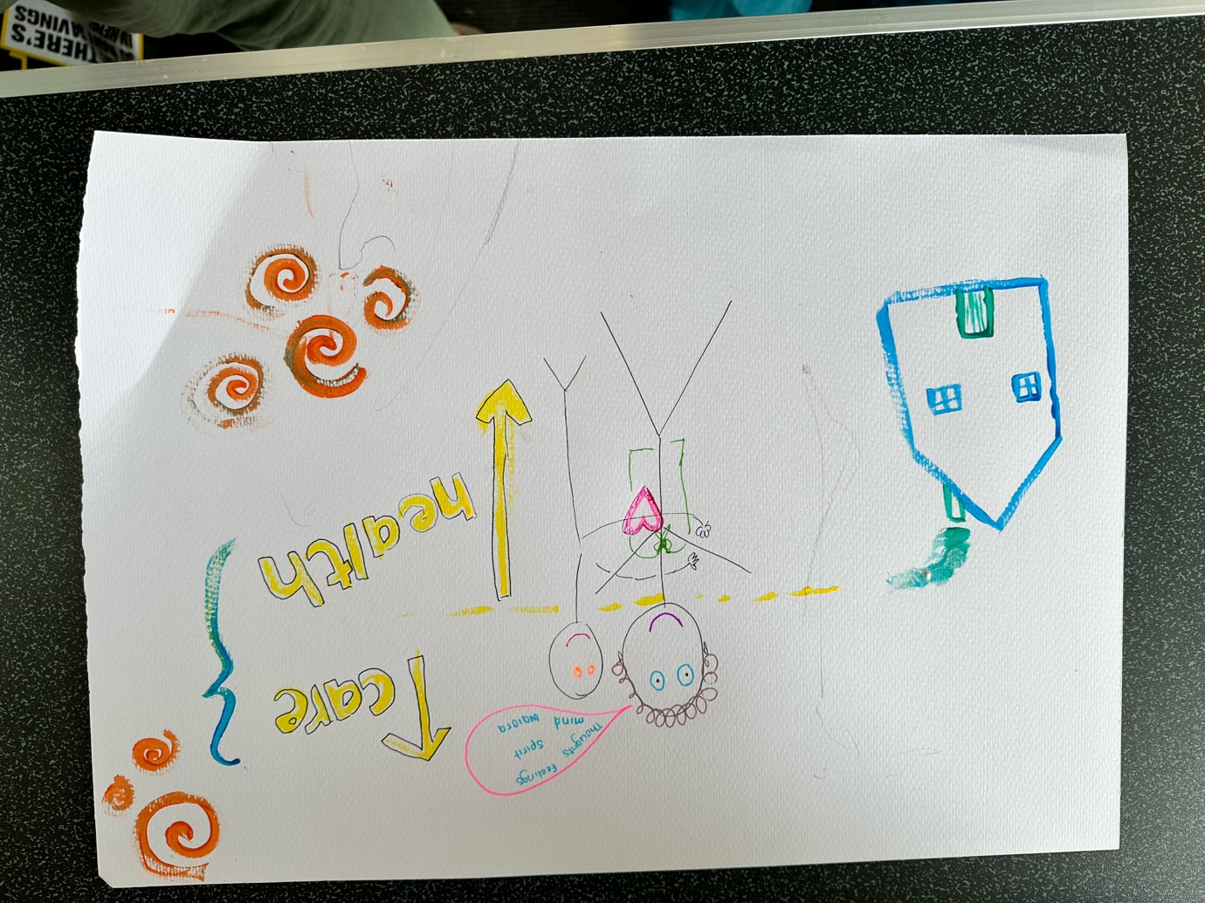

Figure 7 - P18’s body map
Photograph of A4 landscape body map. Including symbols of a house, another person, arrows, labels, speech marks, spiral shapes, the heart detailed onto a stick- figure body.

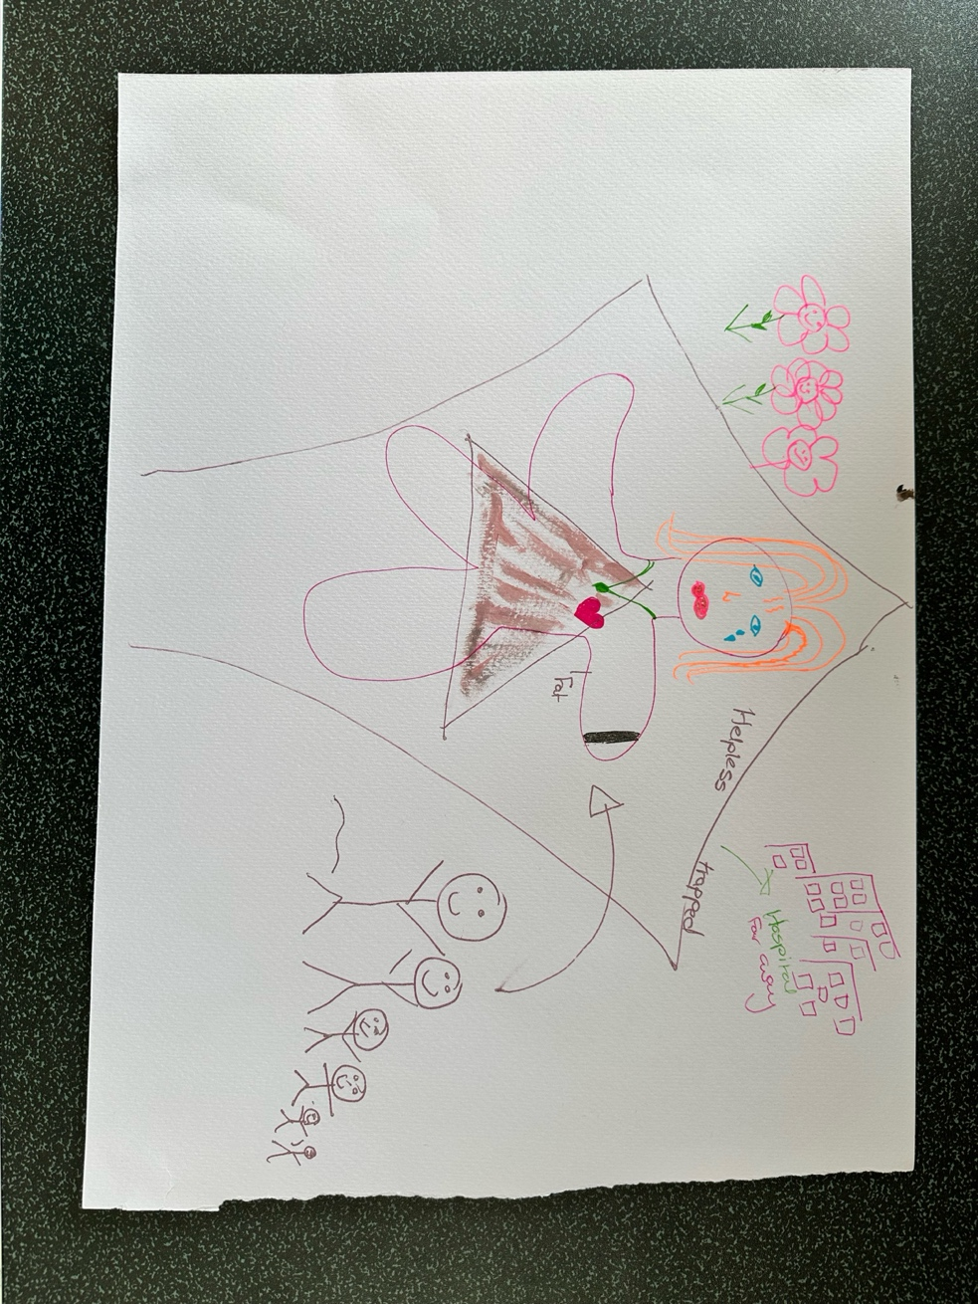

Figure 8 - P17’s body map
Photograph of A4 landscape body map. Including central body expressing emotion of sadness with tears. Pen drawings of flowers, the hospital, people around them. Labels including “trapped”, “Fat” and “Helpless”.

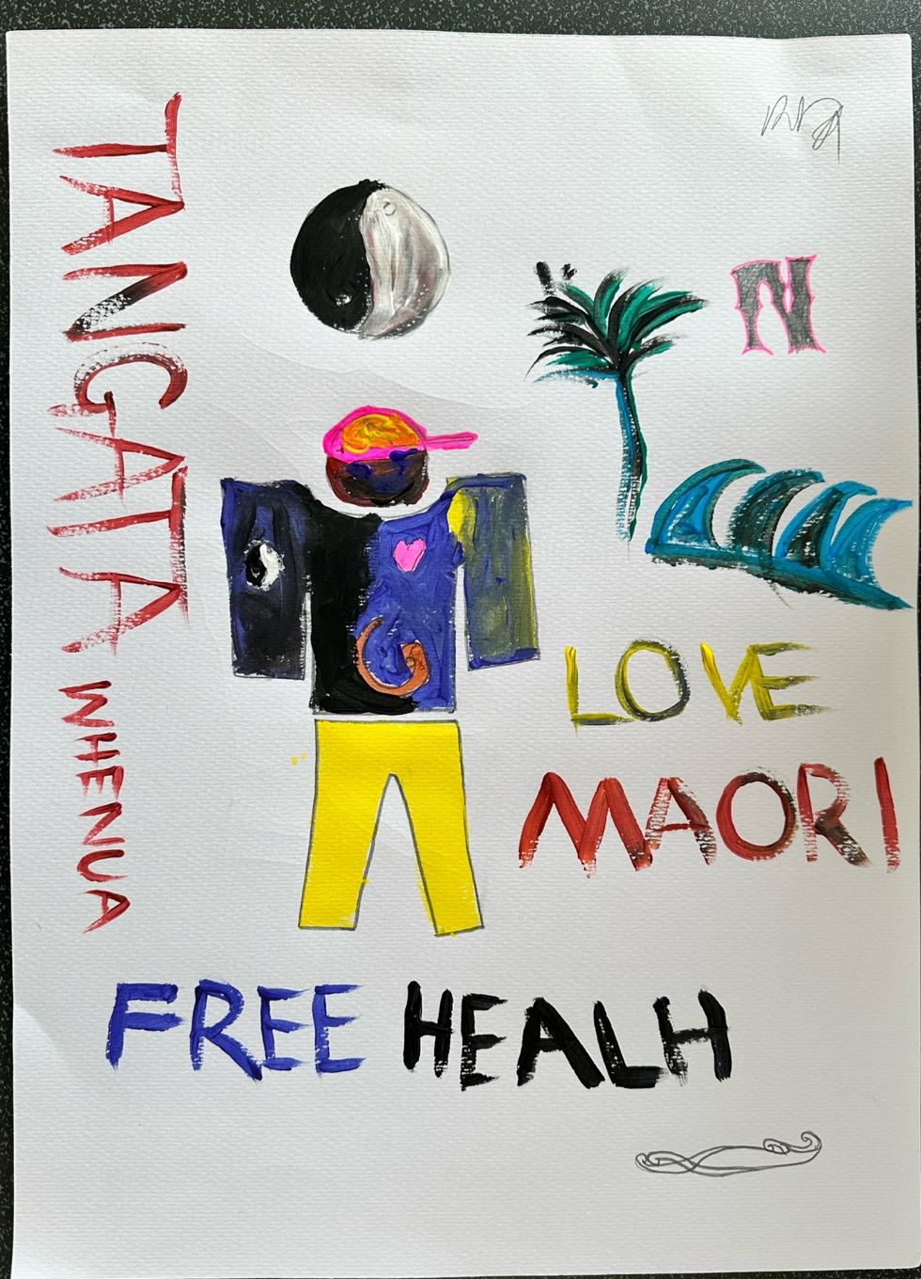

Figure 9 - P21’s body map
Photograph of A4 portrait body map. Including painted symbols: ying and yang motif, the ocean, a tropical tree, a heart, a pencil swirl and the letter “N”. Includes words such as: “FREE HEAL(T)H” “LOVE MAORI” “TANGATA WHENUA” – meaning “people of the land”.

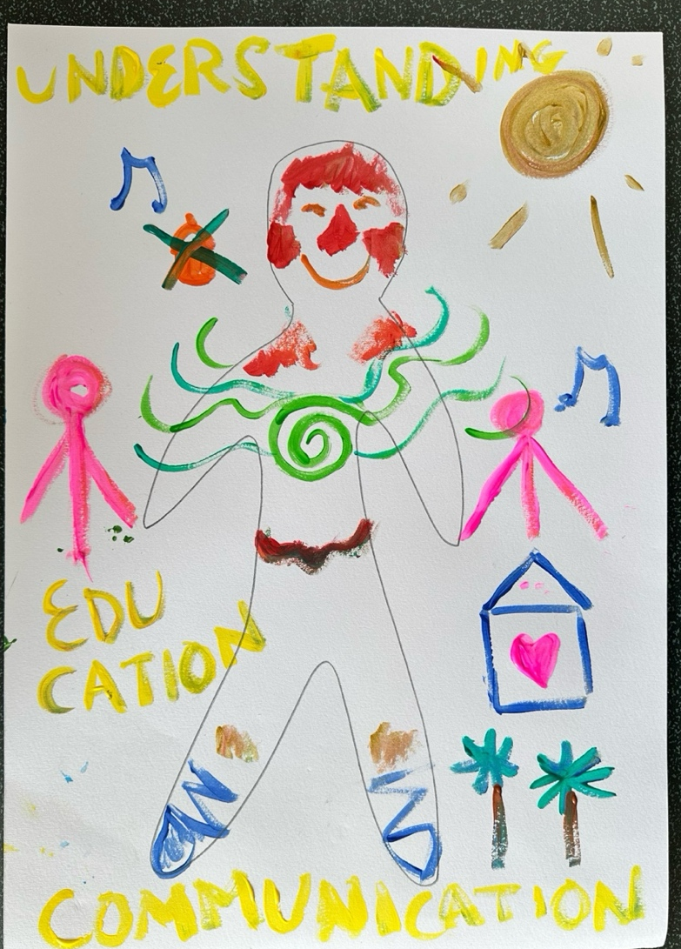

Figure 10 – Researcher’s body map
Photograph of A4 portrait body map. My own painted body map made at the same time as the participants. Includes symbols such as: palm trees, music notes, love heart in a house, two other people, the sun, a cake, ballet shoes. Words used “EDUCATION”, “UNDERSTANDING” and “EDUCATION”.
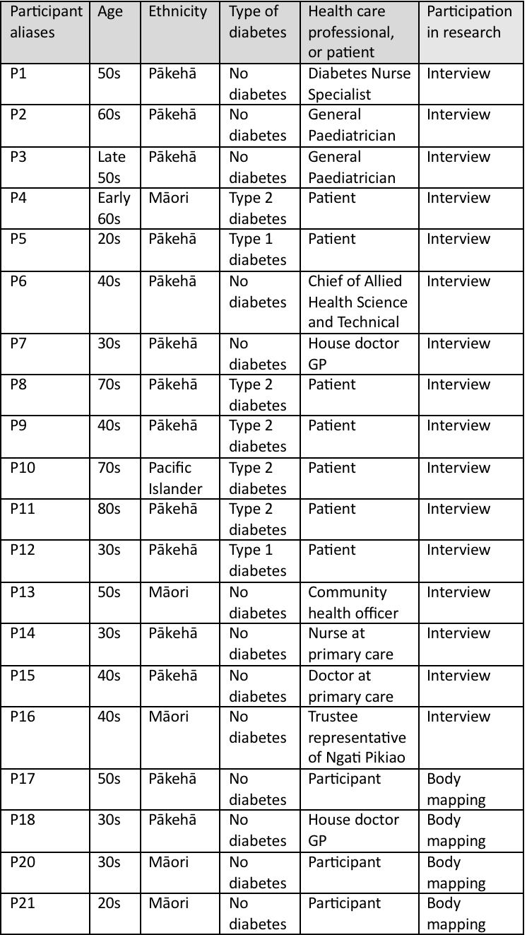
Figure 11 – participant profiles
Detailing the research participants in category of age, ethnicity, types of diabetes, health care professional or patient, and how they participated in research.
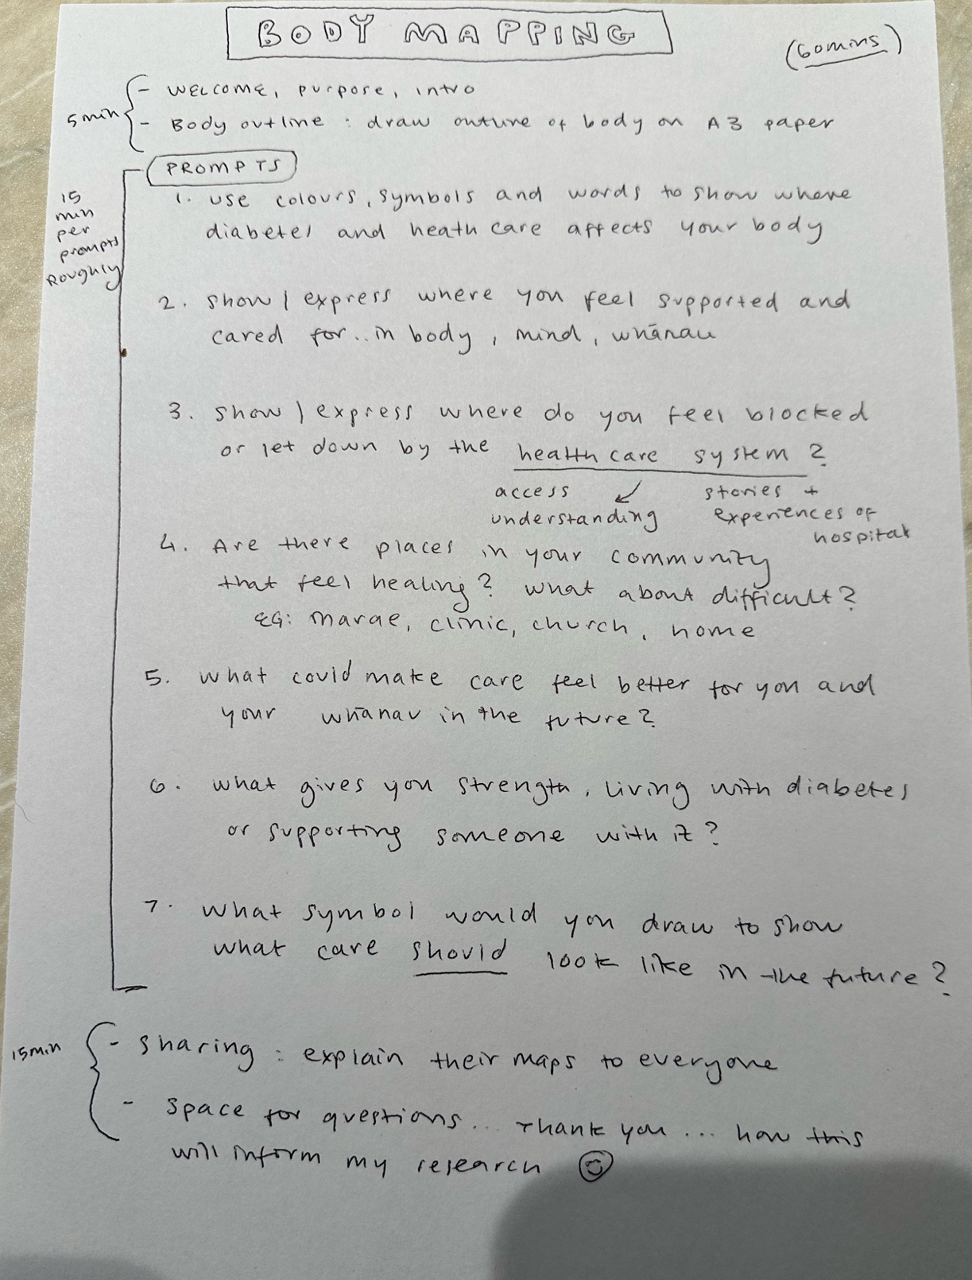

Figure 12 – Body mapping itinerary & questions
Used during the body mapping session at the Marae Tarawai Ponamu.

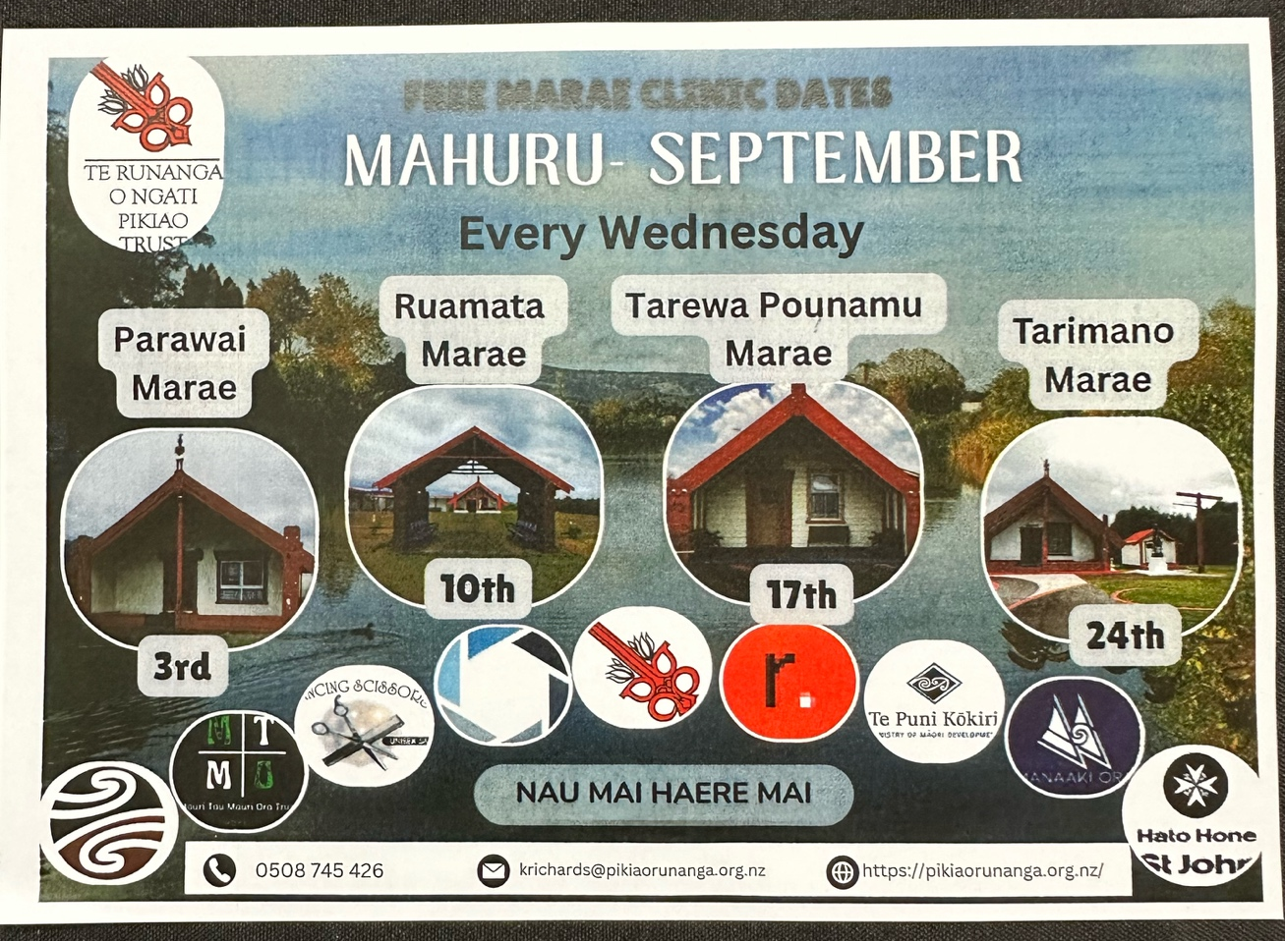

Figure 13 – Leaflet for the “FREE MARAE CLINIC DATES”
This leaflet includes their location, date and services provided at the clinic occurring over the month of September 2025.

